

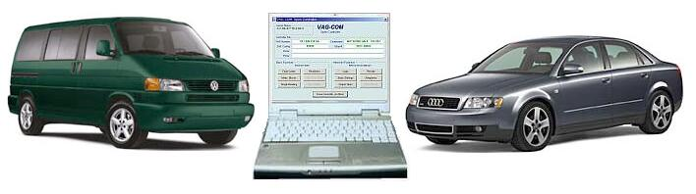

VAG-COM
Diagnostic Software for VW/Audi/SEAT/Skoda
User’s Manual Version 504.1
Copyright (c) 2000-2005
by Ross-Tech, LLC.
920 South Broad Street
Lansdale, PA 19446
+1-215-361-8942
www.Ross-Tech.com

Disclaimer:
All rights reserved, No part of this publication may be reproduced, stored in a retrieval system, or transmitted in any form or by any means, electronic, mechanical, photocopying, recording, or otherwise, without the prior written permission of Ross-Tech, LLC. The information contained herein is designed only for use with VAG-COM. Ross-Tech, LLC. is not responsible for any use of this information as applied to this or other diagnostic equipment.

Neither Ross-Tech, LLC. nor its affiliates shall be liable to the purchaser of this product or third parties for damages, losses, costs, or expenses incurred by purchaser or third parties as a result of: accident, misuse, or abuse of this product or unauthorized modifications, repairs, or alterations to this product, or failure to comply with Ross-Tech, LLC’s written instructions.

By using VAG-COM, you acknowledge that this Program is provided "as is" and "with all faults, defects and errors" and that all use of the Program is at your own full risk. It has been extensively tested, but we cannot guarantee it will work correctly with every system in every car. We will make our best effort to fix any bugs and to enhance the program, but we specifically disclaim any liability for damage to your computer or your car, and we do not promise to have any particular enhancements available on any specific date.

Copyright © 2005 by Ross-Tech, LLC

VAG-COM
Table of Contents
Getting Started | 3-7
Main Screen | 8
Select Control Module | 9
Open Controller Function Screen | 10-11
Fault Codes | 12-13
Measuring Blocks | 14-16
Data Logging | 17-18
Single Reading | 19
Readiness | 20-21
Advanced ID | 22
Login | 23-24
7-digit PIN/SKC Dialog | 25-26
Basic Settings | 27-28
Output Tests | 29-30
Recode | 31-33
Adaptation | 34-35
Security Access | 36-37
Auto-Scan | 38-41
Control Module Finder | 42
OBD-II | 43-44
Applications | 45-46
Options | 47-50
About | 51
Appendix A: Problems & Issues | 52-53
Appendix B: FAQ (Frequently Asked Questions) | 54-63
Appendix C: VAG-Scope | 64-67
Appendix D: TDI Timing Checker | 68-69
Appendix E: VAG Functions | 70

VAG-COM
- Getting Started

Thank you for purchasing VAG-COM. This package allows you to turn a Windows-based PC into a sophisticated diagnostic tool for VW/Audi/SEAT/Skoda models from 1990-2006.

 (Go to our website www.ross-tech.com to download the latest version of VAG-COM. Click on: “Download VAG-COM Software”.)
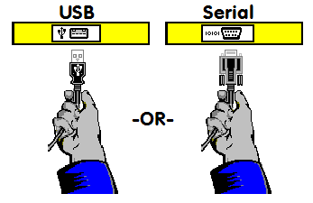

▲ Connect the Serial end of your Serial Interface or the USB end of your USB Interface to the correct port on your PC. If your PC is further from the vehicle than 6 feet, use a Serial Extension Cable between the PC and the Interface (USB is not extendable).

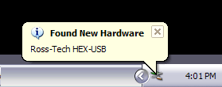
If you are using a Serial Interface, you can skip to page 6 of this manual. If you are using the USB Interface, this message should pop up: ►
Getting Started cont.
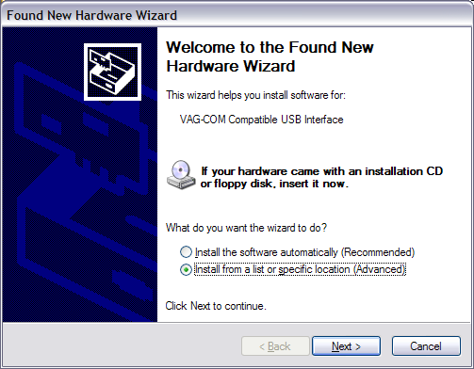

◄ Click on the Found New Hardware message and the Found New Hardware Wizard should start up. If you are prompted with the choice, pick “Not This Time” when asked if you want to connect to the Internet to search for drivers. Select "Install from a list or specific location (Advanced)" then click [Next >]

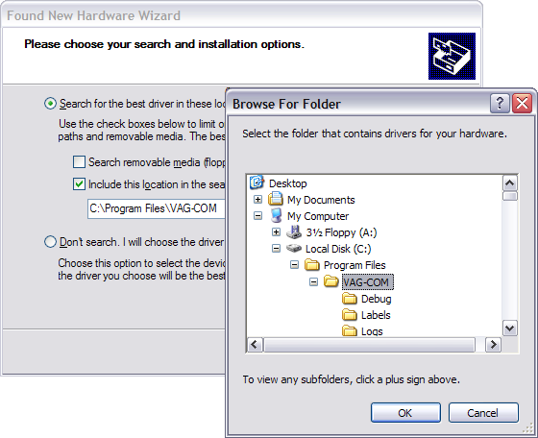

This dialog should appear. ► Select "Search for the best driver in these locations"
Check "Include this location in the search:" Use the [Browse] button to find the VAG-COM folder (Usually C:\Program Files\VAG-COM\, unless you chose a different folder when you installed the software) Click [OK]

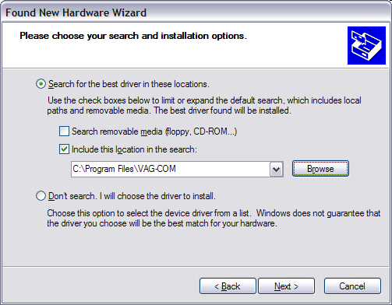

◄ Make sure that you have checked “Include this location in the search:” and that it points to
C:\Program Files\VAG-COM.

Getting Started cont.

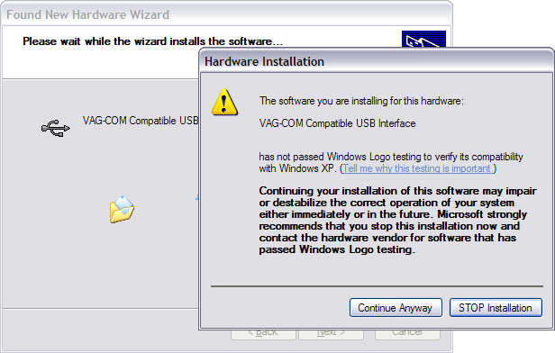

◄Click [Next >] and this dialog should appear:

This dialog warns you that we haven't paid Microsoft a pound of flesh to certify the driver.
You're going to have to click the [Continue Anyway] button..:-)

The following dialog should appear:

Click [Finish] ►

Note: If, for some reason, you installed the USB Interface without following the above instructions, and VAG-COM does not work correctly, go into your PC’s Device Manager while the USB Interface is connected. Find the “VAG-COM Compatible USB Interface” and delete it. Check under “Other Devices”. Then, unplug the USB Interface from your PC, wait 5 seconds and plug it back in. Proceed with the installation from the beginning of the Getting Started section.

Getting Started cont.

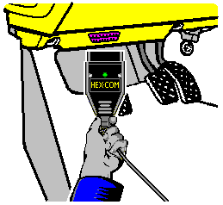

Connect the car end of your
Interface to your vehicle’s Diagnostic Port. ►

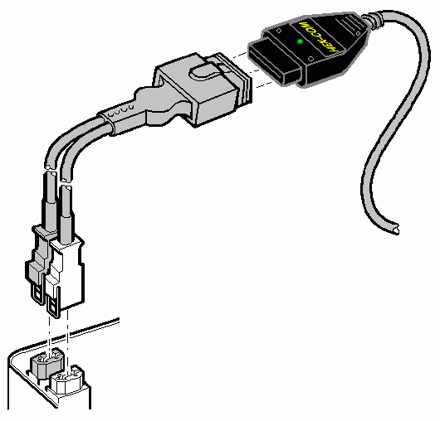

◄ If your vehicle has a 2x2 port (some pre-1996 vehicles), then use a 2x2 Adapter between the Interface and the ports in the car.

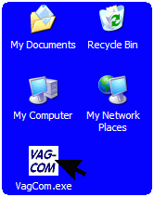

Turn the vehicle’s ignition switch to the ON position. Make sure the key is turned far enough that the dash lights are fully illuminated. The engine may either be running or stopped.

Start the VAG-COM program on your PC through either the Start Menu or the icon on your Desktop. ►

Getting Started cont.

From the Main Screen in VAG-COM (see the Table of Contents for page listing) click the [Options] button to go into the Options screen (see the Table of Contents for page listing).

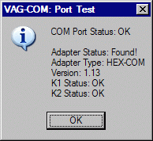
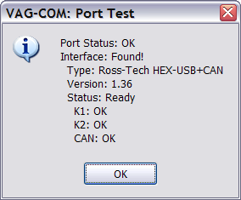

◄ Select the correct port for your PC’s Serial Port (typically COM1 or COM2) or USB Port (USB) and click the [Test] button. Ensure that VAG-COM finds your interface. You should see a message like this.

- If the Adapter Status is not “Found!”, check the connections at the car and PC. Make sure both are plugged in securely.
- Adapter Type should always list the name of the Interface as shown on its sticker.
- If K1 or K2 status are not “OK”, you may have a short or an open circuit in the car’s diagnostic port (most likely caused by the Aftermarket Radio Problem, as shown in the FAQ in Appendix B of this manual). CAN status indicates whether or not the vehicle uses CAN-Bus for diagnostics.

Once you have tested successfully, click [Save] to apply this configuration, you will be returned to the Main Screen.

Click on [Select Control Modules] to view the Select Control Module Screen (see the Table of Contents for page listing). Select one of your car's Control Modules such as Engine

After VAG-COM has connected, click on [Fault Codes] to check for Fault Codes (DTC’s). Repeat the process for each of your car's Control Modules. If you encounter problems, see the FAQ in Appendix B of this Manual first. If you still have problems, feel free to contact us with full details about your PC and vehicle, preferably while you are in front of both.

Note: Your car will not have all the Control Modules listed in VAG-COM, only the ones on the Applications Page for your car. See our Website for more info:
www.Ross-Tech.com/vag-com/cars/applications/

VAG-COM
- Main Screen

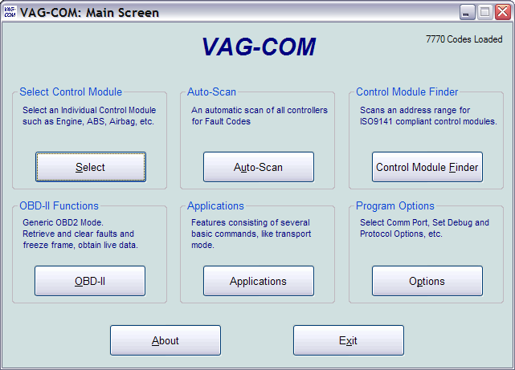

This screen appears when you start VAG-COM by clicking the shortcut on your Desktop or by selecting VAG-COM from the Start Menu.

On this screen, you have 8 buttons that you can click with your mouse:

[Select]
[Auto-Scan]
[Control Module Finder]
[OBD-II]
[Applications]
[Options]
[About]
[Exit] (This closes the VAG-COM program)

VAG-COM
- Select Module Screen

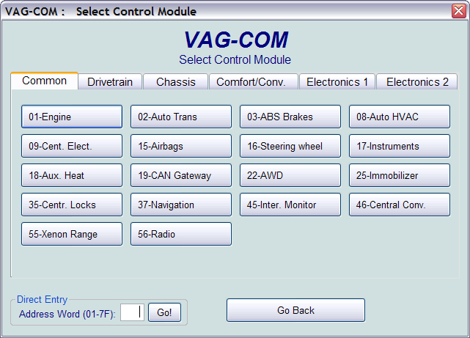
The various computers in the car are called “Control Modules” or “Controllers”. On this screen, you select which Control Module you want to "talk" to. To establish communications with a particular Control Module, simply click on the appropriate button. For example, click on the button for [01 – Engine] to connect to the engine controller. VAG-COM has buttons for all control module addresses currently supported by the VAS-5051 and
VAS-5052 factory diagnostic tools.

Module Tabs
Each tab on the top of this screen contains a number of different controllers grouped by category:Common, Drivetrain, Chassis, Comfort/Conv, Electronics1,and Electronics2. Each possible controller is listed as a number and a description, i.e., [01-Engine]. The number corresponds to the controller number that you'd find in your Factory Repair Manual in the instructions for using a VAG-1551 or other factory diagnostic tool.

Direct Entry
You can also enter any address manually. Simply put in the address and click [Go!]
To return to the Main Screen, click [Go Back]
Note: Your car will not have all the Control Modules listed in VAG-COM, only the ones on the Applications Page for your car. See our Website for more info:
www.Ross-Tech.com/vag-com/cars/applications/

VAG-COM
- Open Controller Screen
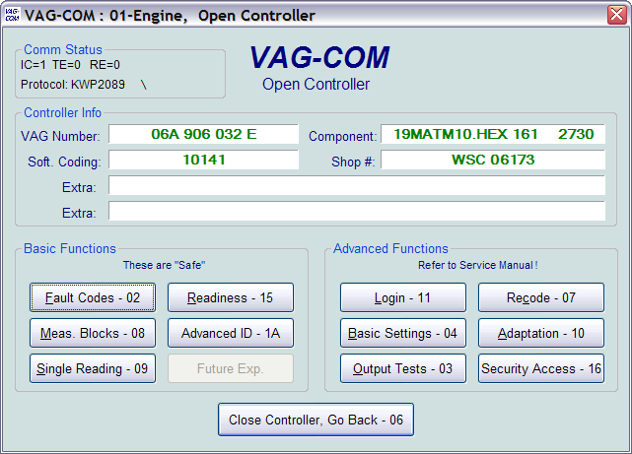
This screen will appear when VAG-COM is attempting to establish communications with any of the Control Modules shown on the Select Control Modules Screen.
Comm Status = Shows the status of the current communications session. Once communications have been established:
- IC= Shows the number of times the session has been initialized. If IC increases beyond 1, communications are less than 100% reliable.
- TE= is a counter of transmitter errors within individual packets. TE greater than 0 can indicate unreliable communication.
- RE= is a counter of receive errors within individual packets. EE greater than 0 can indicate unreliable communication.
- Protocol indicates whether the controller speaks KWP-1281 , KWP-2000 , or CAN-Bus. (See the Function Chart in Appendix E in this manual for more information).
- A rotating cursor shows that communication is active.

Open Controller Function Screen Cont.
Controller Info
Once the communications session has been established, all of the Control Module’s "Identification" data is presented here.
- VAG Number is the VW/Audi part number for this controller.
- Component contains more identification information about the controller and may contain a version number for the controller's internal firmware.
- Soft. Coding is the Software Coding that determines various options for the controller.
- Shop # identifies the WorkShopCode stored in the scan-tool that last Recoded this Control Module. Note: Some older Control Modules are not "codeable" and you may see a Bosch part number or other information in these fields.
- The Extra fields can show VIN and Immobilizer information or slave controller part numbers in some vehicles.
Basic Functions
This grouping of "Safe" functions are used to read various data from the Control Module. VAG-COM checks which functions are supported by each control module and enables the buttons for supported functions only. It is normal for some buttons to be grayed out on some control modules. This is an indication that the control module in question doesn't support those functions. Each of these functions is detailed on the following pages.
Advanced Functions
These functions are capable of making various "programming" changes to the Control Module. You should refer to the Factory Repair Manual for your particular car (or to other documented procedures) before "playing" with these functions. It is completely possible to render your vehicle inoperable or damage components if you make changes in this section without the correct information and training. Each of these functions is detailed on the following pages.

Use [Close Controller, Go Back - 06] to properly close the communications session and return to the Select Control Module screen.

VAG-COM - Fault Code Screen
(VAG 1551/1552 functions 02 and 05)
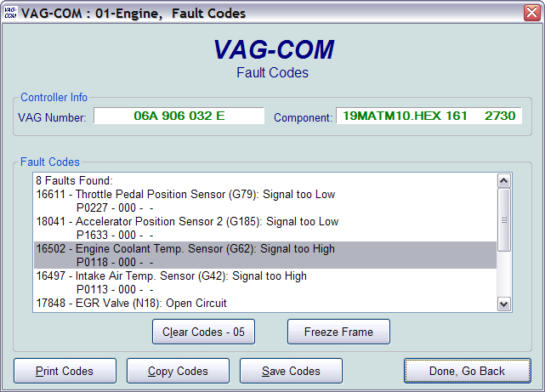
On this screen, VAG-COM shows you any DTC's (“Diagnostic Trouble Codes” or Fault Codes). VAG-COM shows the DTC numbers and also decodes each DTC into
meaningful text.
The 5-digit number is a standardized VAG fault code, which can be searched in the Factory Repair Manuals. The text is a description of the part and failure mode. The letter and number combination in parentheses is the DIN Component Identifier. This is followed by elaborators describing the condition of the fault. The second line contains the P-code, or generic OBD-II code (if it exists, there are thousands of VAG codes without generic OBD-II equivalents).
[Clear Codes - 05] will erase the DTC's from the Control Module's memory. Be aware, this is does not fix the problem that caused the fault! DTC's should only be erased after correcting the condition(s) that caused them in the first place. Note: There is no way to erase individual DTC's while leaving others alone. This is not a limitation in VAG-COM. It's just the way the VAG protocols work.
Fault Code Screen Cont.
[Freeze Frame] adds Freeze Frame data for Fault Codes on control modules using the KWP-2000 protocols. Note: Not all control modules fully support this; very few cars can currently handle freeze-frame data using the VAG proprietary protocols. Self-explanatory messages will appear in place of data when this function is not supported. Currently, the only known ECU's that support this function are the Golf 5 platform cars.

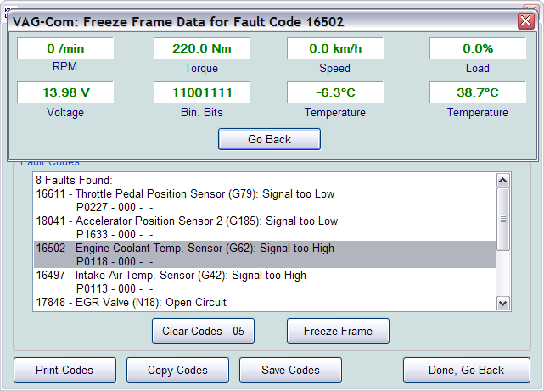
[Print Codes] will print a Fault Code Report. If your PC is not connected to a printer when this button is pressed, be sure to use Windows to set the printer to "Work Off-Line" first! Later, when you connect the PC to a printer, un-check "Work Off-Line" to print the report.
[Copy Codes] will copy your fault codes to Windows Clipboard. Once you have pressed the Copy Codes button, you may paste the results into the application of your choice, such as MS Word or Notepad.
[Save Codes] will save a plain-text Fault Code Report to the VAG-COM/Logs directory of your PC.
[Done, Go Back] takes you back to the main Control Module screen where you can select other functions.

VAG-COM - Measuring Blocks
(VAG 1551/1552 function 08)

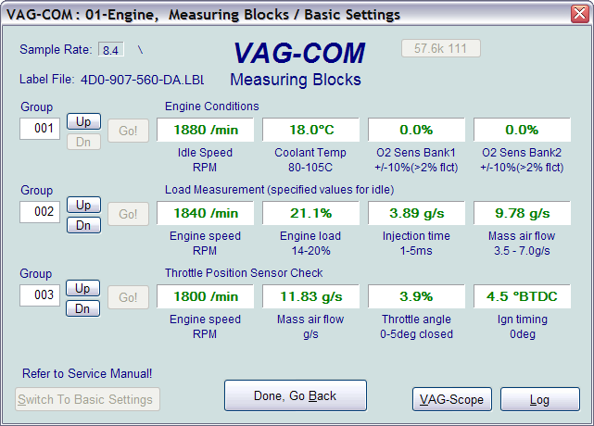
On this screen, you can read all sorts of data from the Control Module in real-time.
Use [Up] and [Dn] to scroll through the available groups (000 - 255 on most Control Modules). Don't become discouraged when you find some that say "ERROR: Group xxx Not Available" or if you find some groups where the fields are all blank. Most 1996 and newer ECU's have Groups in the 200 range, but there are often "gaps" in the numbers.
You can also type a Group number into the Group box and click [Go!]
You can [Log] the data from the measuring blocks. For more information see the Table of Contents for the page listing for Data Logging.
[Switch to Basic Settings] can be used to go to Basic Settings for the Group that is currently being displayed. This should be done only under guidance from the Service Manual or when following some other documented procedure. For more information see the Table of Contents for the page listing for Basic Settings.

Note: Multiple Groups are not permitted in Basic Settings. The [Switch To Basic Settings] button is intentionally disabled if you have groups "running" in the second and third rows. To stop a running group, click on the box that displays the group number (as though you wanted to enter a new number). The button is also disabled on controllers using KWP-2000. On those, you need to go directly to the Basic Settings screen.

The data presented in each Measuring Block Group varies greatly from Control Module to Control Module and between different models and years. Some groups are documented in the Factory Repair Manuals, but many are not. Feel free to explore the Control Modules in your car by scrolling through all the Groups. You can't hurt anything with the Measuring Blocks function!
Measuring Blocks cont.
VAG-COM will attempt to "scale" the raw data coming from the Control Module into real-world units like degrees C, km/h, etc. At the present time, all scaling conversions are to metric units.
Note: Group 000 and any other group that displays 10 fields instead of 4 is an exception. No scaling is possible because the Control Module provides no "Data Type" information with the data for these. Groups of this type can only be displayed in the top row of the screen.
VAG-COM also tries to elaborate as much as possible what the data means. Unfortunately, the "Data Type" information coming from the Control Module is not that precise. For example: VAG-COM can tell that a particular field contains a Temperature, but the data from the Controller doesn't tell us whether this is the Coolant Temperature or the Intake Air Temperature.
To reduce the confusion, VAG-COM supports Label Files and will display the name of the Label File on the top left corner of the screen. When a Label file for the Control Module you are looking at does not exist, VAG-COM will come up with an "educated guess" for what a particular Data Type means. The dealers' VAG-1551 and 1552 scan-tools do not provide any elaboration; they only show what’s in the display fields!
Group 000 supports special Labels. Due to space constraints on the screen, these labels are displayed in a "balloon" when the user clicks on a field:
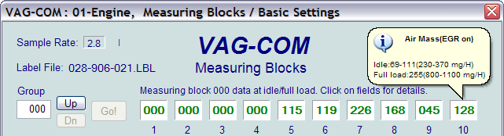
Label Files also allow a third label field to be defined for each of the normal measuring block fields. This label is displayed in a balloon when the user clicks on the field. The idea is to put "specified values" in this field:
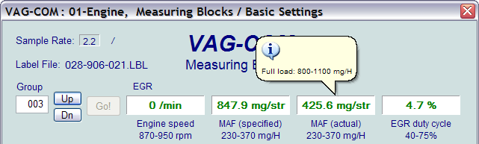
Measuring Blocks cont.
Sample Rate: We can get just over 4.0 samples per second from our '97 VR6 ECU (single group) with the most aggressive protocol-timing settings. This ECU runs at 9600 baud. Most newer ECU's run at 10400 and should give proportionately more. Naturally, if two groups are being displayed simultaneously, the sample rate drops to around 2.0, and 3 groups simultaneously runs at around 1.3. Sample Rate will vary from controller to controller and the PC used will also have some effect. Some controllers (particularly AG4 transmissions and Digifant-III ECU's) use a "hybrid" data-type that requires reading a long header when changing group numbers. Viewing multiple groups still works with these data types, but the sample rate becomes extremely slow. If you see "Reading Header" all the time under the Sample Rate display, you'll know you've got one of these.
In Engine controllers using KWP-2000, there is a [Turbo] button in Measuring Blocks screen. Pressing this button can significantly speed up sampling, for example over 30 samples per second when logging a single group in our Touareg. Once you have pressed [Turbo] you will remain in this High-Speed mode until you exit the Measuring Blocks screen:
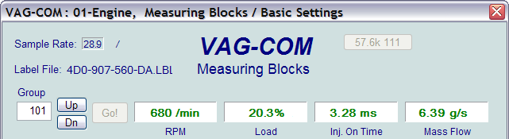
[VAG-Scope] is a plug-in for VAG-COM that allows you to graph Measuring Group Information. See Appendix C for information on VAG-Scope.
Use [Done, Go Back] to return to the Open Controller screen.
Warning!
If you wish to observe real-time data while driving the car, use a second person who is not in front of an active airbag!

VAG-COM
- Data Logging
You can log the data from the Measuring Blocks screen to a .CSV file. These files can be opened and analyzed with Excel or other spreadsheet applications.

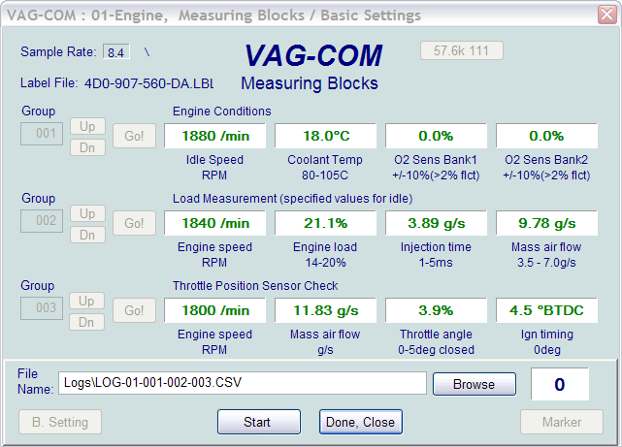

While the Log Dialog is open;
[Start], [Stop], and [Resume] can all be done with the same button. [Start] begins saving the data to a log file.

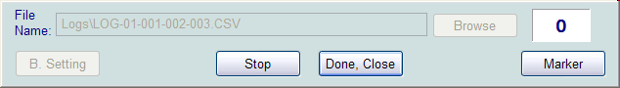

[Stop] discontinues the saving of data to a log file

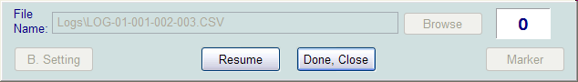
[Resume] continues the saving of data to a log file.
Data Logging cont.
The [Marker] function places a sequential number in the file when you click the Marker button. This can be helpful for data analysis.
The [Browse] button allows you to specify the location for your logs. By default, Log Files will be placed in the LOGS sub-folder in your PC’s VAG-COM directory.

By default, the name of the log file will be the controller number followed by the number for each group number that you are logging. The name can be changed to anything you'd like. If you re-use an existing filename, your new data will be appended to that file.
Switch to Basic Settings is not currently available while logging (but may be added later). However, you can start a log while you're in Basic Settings. If VAG-COM keeps insisting that it can't open a Log file, you're probably missing the LOGS folder and should re-install VAG-COM.

Example using Microsoft Excel:
1. Choose datablock you want to view.
2. Click [LOG] button
3. Use default file name if desired. It will append the old file if you use a particular name more than once.
4. Click [DONE] when you're finished logging data.
5. Open Microsoft Excel
6. Click File->Open (change filetype to all *.*)
7. With mouse select the columns you want to graph.
8. Click the Chart Wizard button.
9. Select XY (Scatter) and click one of the formats that has lines.
10. The chart wizard will prompt you to name axes if you want.
You can also use the [VAG-Scope] plug-in for VAG-COM that allows you to replay LOG files. See Appendix C for information on VAG-Scope.
Warning!
If you're going to use VAG-COM while you're driving, please use a second person! Let one drive while the other observes the data, making sure the person holding the PC is not in front of an active airbag! Obviously, do not break any laws, speeding or otherwise while using VAG-COM!

VAG-COM
- Single Reading
(VAG 1551/1552 function 09)
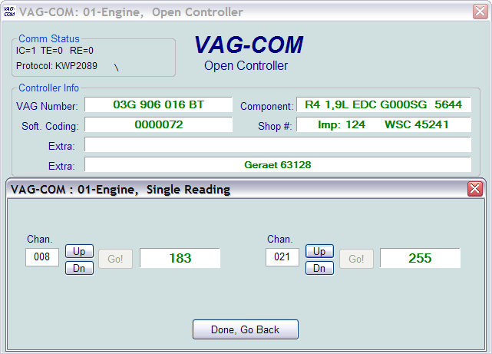

This function allows you to look at real-time data from control modules that support it. However, the data stream coming from the control module gives NO CLUE what the data means or how to scale it into real-world values.
The only way to know what the values mean is to find a reference to this function in the Factory Repair Manual for your car.
This function is rare, but it is used, for example, with some OBD-I 2.8L 12V V6 engines.
The very name of this function annoyed us, so we added a twist. You can look at two channels of "Single Readings" at once!
Use [Done, Go Back] to return to the Open Controller screen.

VAG-COM
- View Readiness
(VAG 1551/1552 function 15)

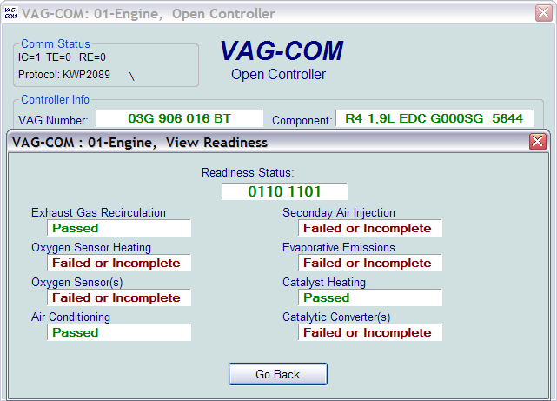
The Readiness Code is a set of 8 bits, each of which corresponds to one monitored emissions "system" in an OBD-II car. When all readiness bits show "pass", it means that all systems have been checked and pass the on-board tests.
Whenever you clear DTC's or remove power from the ECU, all readiness bits will be set to "fail". Most cars do not have all 8 systems, so as soon as you apply power again, the bits corresponding to systems that are not actually in the car will come up "Passed" again.
The above screen-shot was taken immediately after clearing the DTC's. You can see that this car does not support "monitors" for the EGR, Catalyst Heating, or Air Conditioning because this specific car does not have EGR or Catalyst Heating. It does have Air Conditioning, but a "monitor" is only required if the system uses ozone-depleting refrigerant (R12).
It takes a variety of specific driving conditions to "test" all the systems. It can be done in a short time using a very specific and complicated procedure found in the On Board Diagnostic section of the Factory Repair Manual for your engine. The alternative is just to drive the car for 2-3 days. Make sure you include at least one short highway trip, and your Readiness Bits should all read "Pass" again.
Use [Go Back] to return to the Open Controller screen.

View Readiness cont.

VAG-COM also Decodes Readiness bits into meaningful data on modern TDI engines
(a VAG-COM exclusive, not even the VAS-5051/5052 do this!):
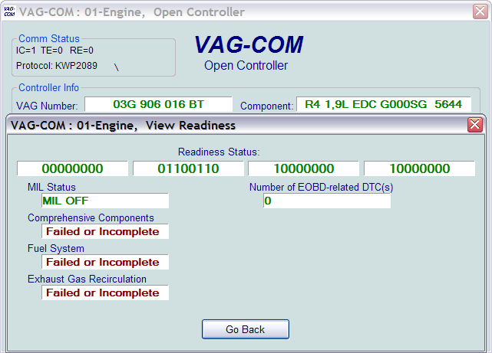
Note:
This function is only available on Engine Controllers that are OBD-II compliant (all 1996 and newer US-Model gasoline engines).
Non-US models and TDI's may not support this function even though they are otherwise OBD-II compliant. OBD-I did not require any "monitors".
12V 2.8L V6 engines may have readiness bits stored in or near Measuring Block
Group 029.

VAG-COM - Advanced ID Screen
(VAS 5051/5052 “Identification Services”)
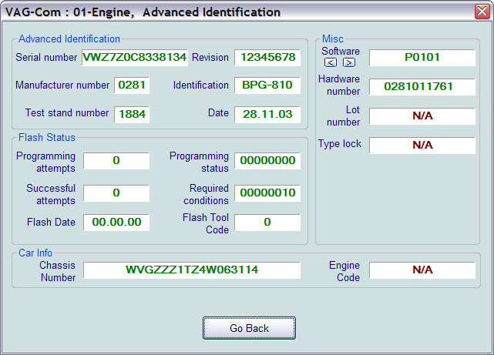

Corresponds to VAS-5051/5051 "Identification Services"
The Advanced ID function is only supported by control modules using the KWP-2000 and CAN Protocols!
Note: The amount of data appearing on this screen will vary based on what the control module supports. "N/A" in red means that data isn't available from that module. Some fields (like Chassis Number) may be blank if the module has never had a chassis number "installed".
You can use the small [<] and [>] buttons under Software to get version information for various portions of the firmware in the control module.
Use [Go Back] to return to the Open Controller screen.

VAG-COM
- Login
(VAG 1551/1552 function 11)

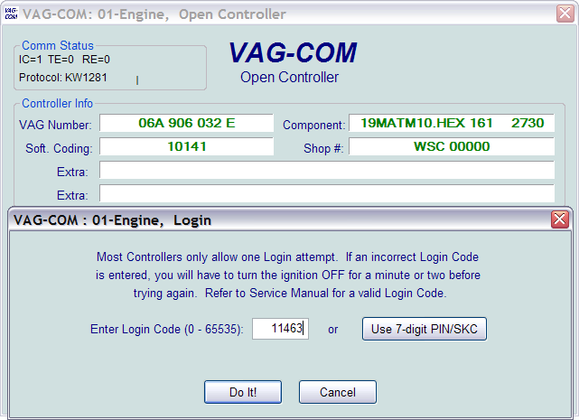
The Login Function must be used on some (but not all) Control Modules before you can Recode or change Adaptation values. On others, it "enables" certain features like cruise control. Valid Login codes can be found in the Factory Repair Manual for your car.
If working on an Immobilizer, select [Use 7-digit PIN/SKC] to enter a 7-digit Secret Key Code. For more information see the Table of Contents for the page listing for PIN/SKC.
Use the [Do It!] button to save the Login and return to the Select Function Screen.
Use the [Cancel] button to cancel the Login and return to the Select Function Screen.

Login Dialog cont.
The following warning appears in the upper right corner of the screen if a session is disconnected after you have done a Login. You will need to exit the Controller and do another Login.
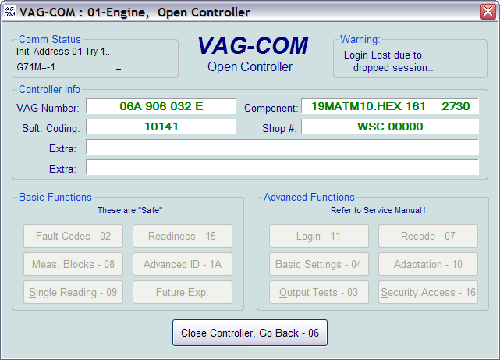
The most common cause of this is the use of an incorrect login code or a 7-digit PIN/SKC based on an incorrect Immobilizer ID or incorrect data entered in the 7-digit dialog.

VAG-COM
- 7-digit PIN/SKC Dialog

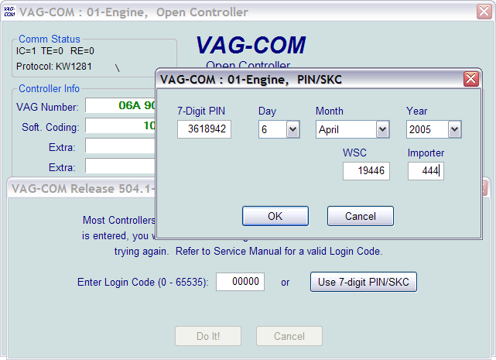
The 7-digit PIN/SKC (Secret Key Code) dialog is used for Key Matching and Immobilizer 3 Adaptation.
You must enter the following information:
- 7-digit SKC that the dealer generated for your exact Immobilizer ID Number.
- Date on which the SKC was GENERATED BY THE DEALER.
- Workshop Code (WSC) for the dealer that generated the SKC.
- Importer Number for the dealer that generated the SKC.
The 7-digit SKC is useless without these other items.

When you have filled in all of the data click [OK]. If any of the entered data does not make sense, the following message may appear:
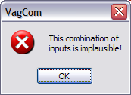
When you have successfully submitted the 7-digit PIN/SKC, you are taken back to either the Login or Adaptation screen (wherever you were when you clicked on
[Use 7-digit PIN/SKC] ). Now, you should have “XXXXX” in Login or Adaptation value.
7-digit PIN/SKC Dialog cont.

Notes:
Unlike the factory diagnostic tools, with VAG-COM, the same PIN can be used for a particular car at any time in the future, as long as you keep track of the PIN, along with the Date on which the PIN was GENERATED BY THE DEALER, the dealer's Workshop Code (WSC) and the Importer number.
If you obtain a 7-digit SKC, but the dealer has not provided the WSC, look at the window stickers of vehicles on the dealer's lot. The dealer number will be listed next to the name and address of the dealer. In the US, the dealer number will be a 4 followed by five more digits, for example 401742. To obtain the WSC, delete the 4 and simply use the remaining five digits, 01742 in the above example.
The Importer number should be:
444 for all dealerships in the US
999 for all dealerships in Canada
995 for all dealerships in France
Use the [OK] button to save the 7-digit information and return to the Login or Adaptation screen
Use the [Cancel] button to return to the Login or Adaptation screen without saving.

VAG-COM
- Basic Settings
(VAG 1551/1552 function 04)

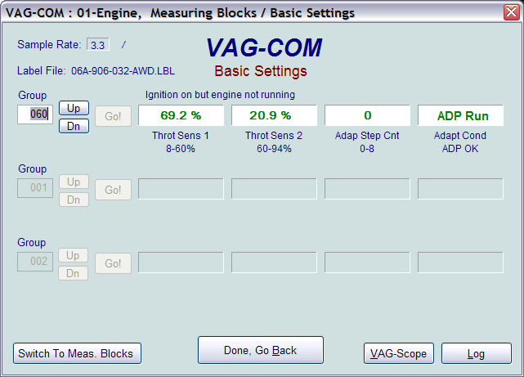
This screen is presented when a Control Module is in Basic Settings Mode.
Basic Settings Mode is very similar to Measuring Blocks, and the contents of each display group is the same. The difference between the functions is that the Control Module may try to perform various calibrations while in Basic Settings mode.
Warning!
You should refer to the Factory Repair Manual for your particular car (or some other documented procedure) before "playing" with the Basic Settings function. Failure to follow the proper procedures can result in serious damage to the vehicle.
Although you can use the [Up] and [Dn] buttons to scroll through the available groups just like on the Measuring Blocks screen, this is probably not a good idea since you may put the Controller into Basic Settings for a Group that you did not intend.
You can also enter a Group number directly and click [Go!]

[Switch to Meas. Blocks] will switch back to the passive (and "safe") Measuring Blocks mode.
Notes:
Multiple Groups are not permitted in Basic Settings. The data presented in each Basic Settings Group varies greatly from Control Module to Control Module and between different models and years. Some groups are documented in the Factory Repair Manuals, but many are not.
Basic Settings cont.

VAG-COM also tries to elaborate as much as possible what the data means. Unfortunately, the "Data Type" information coming from the Control Module is not that precise. For example: VAG-COM can tell that a particular field contains a Temperature, but the data from the Controller doesn't tell us whether this is the Coolant Temperature or the Intake Air Temperature.
To reduce the confusion, VAG-COM supports Label Files and will display the name of the Label File on the top left corner of the screen. When a Label file for the Control Module you are looking at does not exist, VAG-COM will come up with an "educated guess" for what a particular Data Type means. The dealers' VAG-1551 and 1552 scan-tools do not provide any elaboration; they only show what’s in the display fields!
Use [Done, Go Back] to return to the Open Controller screen.
The most common use for the Basic Settings function is to recalibrate the Throttle Body. Another common use for Basic Settings is to bleed the ABS Hydraulic Unit on newer cars. Please refer to a Factory Repair Manual for your car before attempting to do this!

You can begin and end a Data [Log] while in Basic Settings. For more information see the Table of Contents for the page listing for Data Logging.

Basic Settings in KWP-2000:
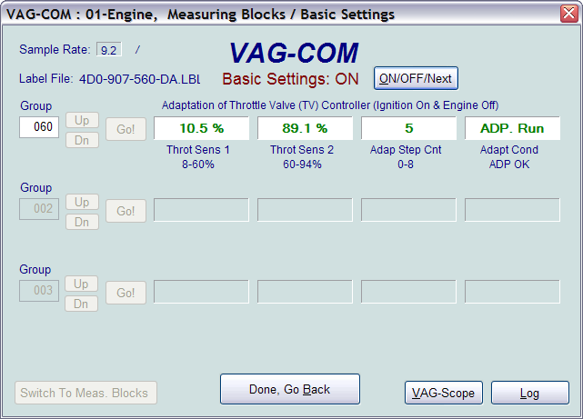
On Controllers using KWP-2000, there is an [ON/OFF/Next] button that allows you to initiate and exit Basic Settings while still being able to see the values in the measuring groups.

VAG-COM - Output Tests
(VAG 1551/1552 function 03)

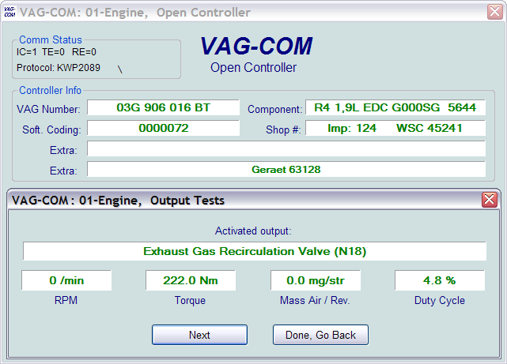
The Output Tests function is used to test a Control Module's Electrical Outputs (and the wiring that connects it to the various devices). Output Tests under KWP-2000 includes simultaneous measuring data when available from the control module in question.
To begin Output Tests, and to progress through each step, click [Start/Next].
Notes:
The Outputs that can be tested and the sequence in which they become active is controlled strictly by the Control Module; this is not a function of the Diagnostic Tester. To find out which Outputs can be tested and the sequence in which they will become active, please refer to the Factory Repair Manual for your car.
Once the Test Sequence once it has been started, clicking [Done, Go Back] will take you back to the Open Controller Function Screen. THE TEST SEQUENCE WILL STILL BE ACTIVE!

Most Control Modules will permit the Output Test Sequence to be run only one time per session. If you run the Test Sequence to completion, VAG-COM will allow you to return to the previous screen without closing the session, but you may not be able to run the Output Test Sequence again. If you need to run the Sequence again, manually Close the Controller and re-start the session. On some cars, you must cycle the key OFF and ON or even start the engine (to clear the cylinders of fuel).
Some Outputs require additional action before they become active. Fuel Injectors are a common example. To activate a Fuel Injector, you must press (and in some cases release) the gas pedal. Exact details can be found in your Factory Repair Manual.
Output Tests cont.
On most systems, the Output Tests function is only available when the Engine is not running.
It is perfectly normal to see a "short to ground" message in the process of running Output Tests. The ECU identifies which output it is currently testing by sending a fault-code number. On many ECU's the full text for this fault code includes "short to ground". Why? Because one side of the actuator in question has 12V on it all the time and the ECU completes the circuit (and turns the actuator on) by pulling the other side to ground.
Warning:
Do not use the Output Tests function on any system while the car is in motion! Running Output Tests on the ABS brake system can temporarily disable the brakes entirely and cause individual wheels to lock and unlock.
We strongly suggest you refer to the Factory Repair Manual for your specific car before running Output Tests on any Control Module so you will know what to expect!
If you try to perform Output Tests on an Airbag controller, the following warning will pop up:
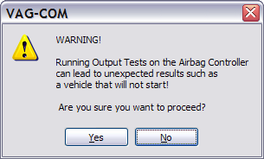
For example, in the VW Touareg, a specific procedure must be performed to be able to start the vehicle if Output Tests on the Airbag Controller have been performed.
Use [Done, Go Back] to return to the Open Controller screen.

VAG-COM - Recode or Long Coding
(VAG 1551/1552 function 07)

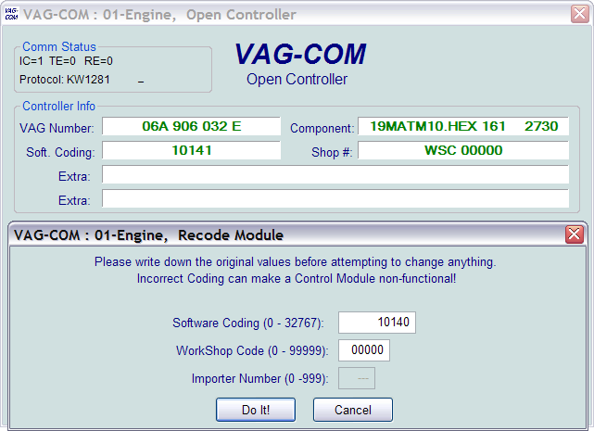
Recode is used to set various options in a Control Module.
Warning!
You should refer to the Factory Repair Manual for your particular car (or some other documented procedure) before attempting to Recode a Control Module. At the very least, write down the original values. There is no other way to "undo" or restore the original values if what you're trying to do doesn't work out.
Note:
Some Modules require a valid Login before you can re-code them.
A feature unique to VAG-COM: You can leave the Work Shop Code unchanged, or enter any workshop code you desire. Certain other programs always leave a tell-tale WSC when you re-code a module.
The Importer Number is only relevant for recoding controllers that use KWP-2000. By default, this will remain unchanged unless you have set up an Importer Number in the Options screen.

Recode cont.

Up to 20 lines of coding chart data can be included in a Label File. This data is shown in a balloon on the coding screen:

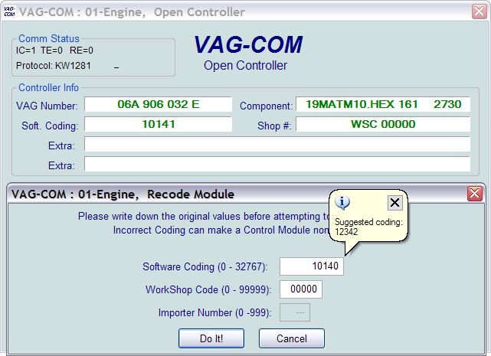
When coding new Airbag Modules in many VW models, VAG-COM can "Suggest" an appropriate Coding value. Disclaimer: We cannot guarantee that the coding which VAG-COM may suggest will be correct, but there should be no harm in trying it. If it's not correct, the control module should simply refuse to accept it and the coding will remain at 00000.
Recode cont.
Long Coding. This function is needed to Recode some control modules (especially Gateways) in the newest cars which use CAN for diagnostics. Due to the complexity of Long Coding strings (up to 255 bytes of hexadecimal data) we've accommodated (and urge) the use of Copy & Paste in this function:
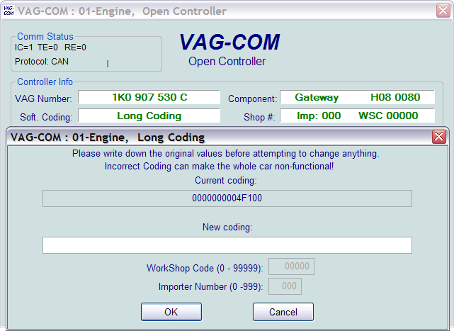
Use the [Do It!] button in Recode or the [OK] button in Long Coding to save the new Soft Coding to the controller and return to the Open Controller Function screen.
Use the [Cancel] button to return to the Open Controller Function screen without saving.

VAG-COM - Adaptation
(VAG 1551/1552 function 10)

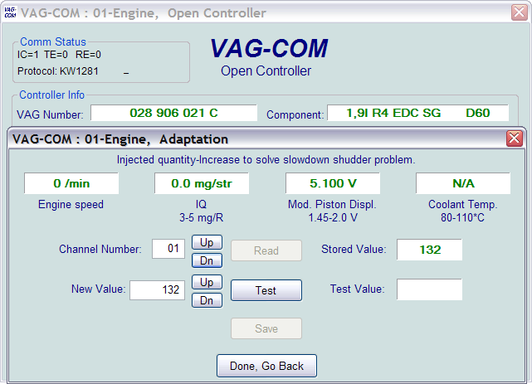
The Adaptation function allows you to alter certain values and/or settings in control modules which support it.
Warning!
You should refer to the Factory Repair Manual for your particular car (or some other documented procedure) before "playing" with the Adaptation function. However, many available Adaptation Channels are totally undocumented!
You can use the [Up] and [Dn] buttons next to Channel Number to scroll through all 99 possible channels, or you can manually enter a channel number and click [Read]. If a channel exists, VAG-COM will show you the Stored Value. If a channel does not exist, the Stored Value will show as "N/A". Other data the controller may or may not send will be decoded and shown in the four display fields at the top of the screen.
Once you have reached a channel of interest, you can use the [Up] and [Dn] buttons next to New Value to incrementally change the value. Or you can directly enter a New Value and click [Test]. This will tell the controller to temporarily use the new value so you can evaluate it's effects.
When you are satisfied with the effect of a New Value, you can store it in the Controller permanently by clicking [Save].

Adaptation cont.

Notes:
Channel 00 is a special case. Performing a [Save] to Channel 00 resets all adaptation values to their original factory defaults. This only works in controllers that support this function, see your Factory Repair Manual to find out if this procedure applies to each controller in your vehicle.
Some Engine and Immobilizer controllers will require a valid Login before permitting you to [Test] or [Save] Adaptation values.

Values put in with [Test] but not Saved will persist until controller is powered-down.

Label Files can support values and description for Adaptation channels. This help chart is displayed in a balloon:
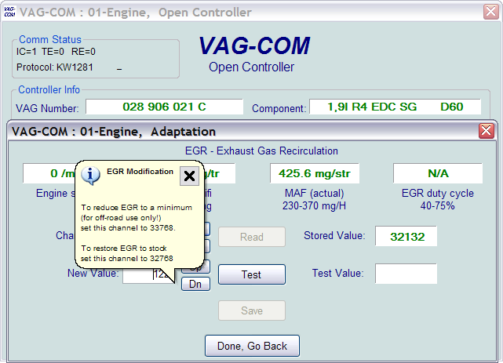

Click [Done, Go Back] to return to the Open Controller Function Screen.

VAG-COM - Security Access Screen
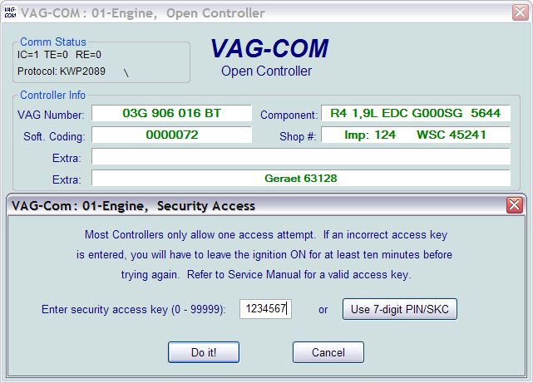
(VAG 1551/2 Function 16, KWP-2000 only)

The Security Access Function must be used on some (but not all) KWP-2000 Control Modules before you can Recode or change Adaptation values. On others, it "enables" certain features like cruise control. Valid Login codes can be found in the Factory Repair Manual for your car.
Security Access cont.
The Security Access Function supports 7-Digit SKCs. This is needed for Immobilizer Functions (such as key programming) on the latest vehicles like the Touareg:
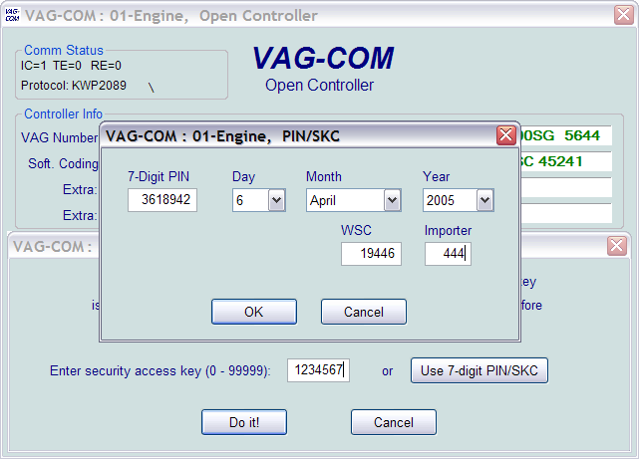
For more information see the Table of Contents for the page listing for 7-digit PIN/SKC.
Use the [Do It!] button to save the Login and return to the Select Function Screen.
Use the [Cancel] button to cancel the Login and return to the Select Function Screen

VAG-COM - Auto-Scan
(VAG 1551/1552 function 00)

This function scans each controller in the vehicle to retrieve controller information (VAG number, Component number, Soft. Coding, WSC, and fault codes).
First, you must Select Chassis Type:
There are dozens of different control modules that exist across the entire range of VW/Audi vehicles. No one car has all Modules! Newer cars have more, older cars have fewer. Because of this, you must select a Chassis Type that contains only those modules that are plausible for a given chassis.
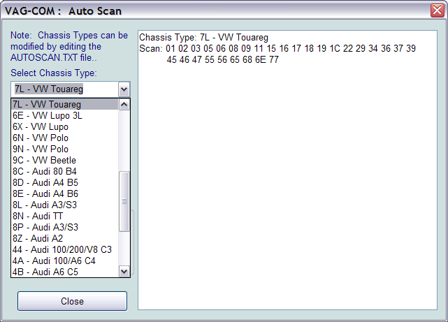
There is a file in the VAG-COM directory called AUTOSCAN.TXT, which contains all of the vehicle profiles. You may edit this with a Text editor (like Notepad) to create a custom profile for your vehicle. To help you figure out which controllers are in your car, you can run the Control Module Finder, see the Table of Contents for the page listing.
Auto-Scan cont.
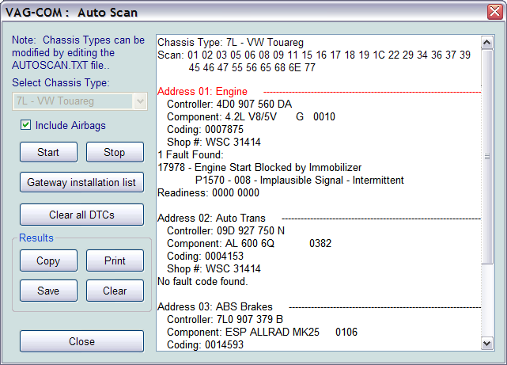
[Start]
This begins the Auto-Scan. Beware; this process can take several minutes. While the scan is running, VAG-COM will cycle through the Open Controller and Fault Code screens for each controller before returning to the Auto-Scan screen. Beware; this process can take several minutes. Double-clicking on any of the Control Module names in RED will open the Fault Codes screen for that controller and allow you to clear the codes.
[Stop]
This stops the Auto-Scan.
Auto-Scan cont.
[Gateway Installation List]
Usually available only on Gateways in cars using a direct CAN connection for diagnostics (new A8 and all Golf-5 chassis cars). This very fast function takes about 3 seconds to query the car's Gateway to find out what modules are installed in the car and what their status is. Any modules having fault codes should show a "Malfunction". Modules are directly accessible from this screen by double clicking on the appropriate line. The following screen-shot is from a Golf-5 in Europe:
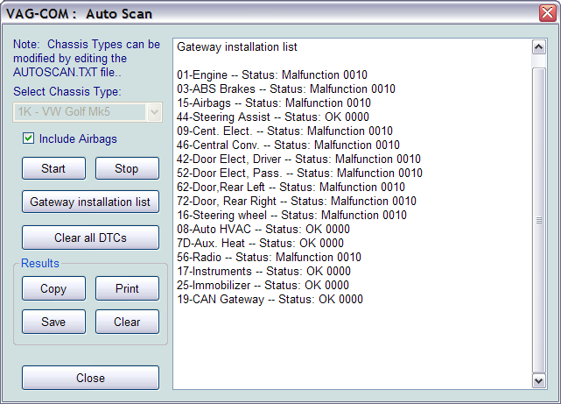
Auto-Scan cont.
[Clear All DTC's]
This function is implemented in two ways. On pre-CAN-Bus vehicles, VAG-COM will access each control module and clear DTCs from each one individually. On vehicles using CAN-Bus for diagnostics, VAG-COM performs this function without accessing all the control modules individually.
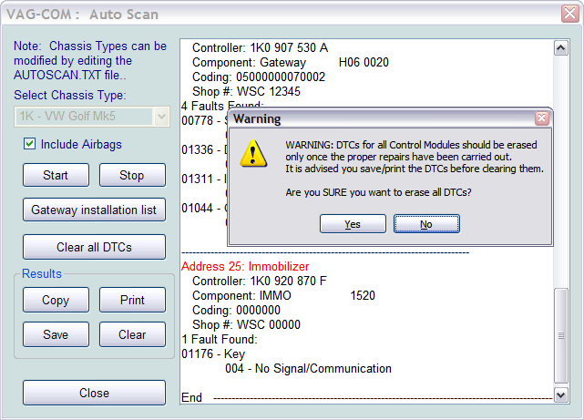
Results:

[Copy]
If you close the Auto-Scan dialog, any data in its output box will be lost. If you would like to keep a record, click the [Copy] button first, then you can then paste the results into the application of your choice, such as MS Word or Notepad.
[Print]
This function sends the results to your printer.
[Save]
This function saves the results to a text file in our VAG-COM\Logs directory.
[Clear]
This erases your results. It does not clear any fault codes from any Controllers.

To return to the Main Screen, click [Close]

VAG-COM - Control Module Finder

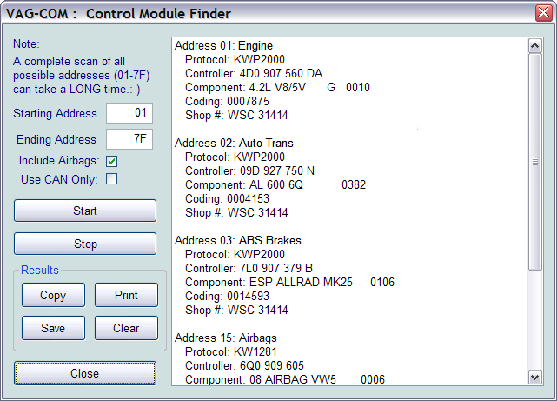
This function cycles through each possible address in the vehicle, finding each controller and reporting its Address, Protocol, Controller VAG Number, Component Number, Soft. Coding, and Work Shop Code.
Note: No one car has all Modules! Newer cars have more, older cars have fewer.
If you check Use CAN Only then the Module Finder will not check for any modules on the K-line.
[Start] begins the finder. Beware; a "full" scan can take 45 minutes or more. Of course, you can scan selected address ranges.

[Stop] stops the finder.
Results:
[Copy] If you close the Auto-Scan dialog, any data in its output box will be lost. If you would like to keep a record, click the [Copy] button first, then you can then paste the results into the application of your choice, such as MS Word or Notepad.
[Print] This function sends the results to your printer.
[Save] This function saves the results to a text file in our VAG-COM\Logs directory.
[Clear] This erases your results.
To return to the Main Screen, click [Close]

VAG-COM - OBD-II
(VAG 1551/1552 Address Word 33)

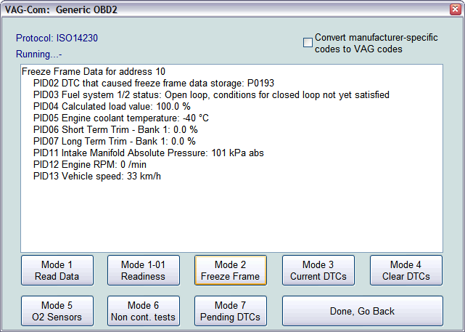

Generic OBD-II functionality. Because many of VW's recent factory repair manuals no longer have traditional 01-Engine "On Board Diagnostic" information and have replaced it with "Generic Scan Tool" data, this has become much more important than it was in the past. For now, we'll let the screens speak for themselves. Click each of the Mode buttons to for each OBD-II function.
Generic OBD-II functionality is "Supported" only on VW, Audi, Seat, and Skoda cars. It will likely work on many other brands of cars. We'd be happy to receive feedback as to what other brands and models of cars it does and does not work on, however, we do not feel obligated to make it work on other manufacturer's cars.
Generic OBD-II functionality is limited to cars using ISO 9141-2 ("CARB"), ISO 14230 ("KWP-2000") and ISO-15765 ("CAN") protocols. Our interfaces do not support the SAE J1850-VPW and J1850-PWM protocols used by most US-market GM and Ford products, so this cannot work on those cars. Most early (1996-2000) OBD-II compatible Chrysler cars used ISO-9141-2. Many newer Chrysler cars use SAE-J1850 and are incompatible. Most European and Asian cars use ISO and should be compatible. In US models, Generic OBD-II compatiblilty was required as of model year 1996. In Canada, 1998. In the European Market, 2001 (gasoline-powered) and 2004 (diesel-powered).
Please see the FAQ in Appendix B:
What's the difference between VAG-COM and an OBD-II Scan-Tool?
To return to the Main Screen, click [Done, Go Back]

OBD-II cont.
VAG-Scope is able to graph generic OBD-2 Mode 1 data:
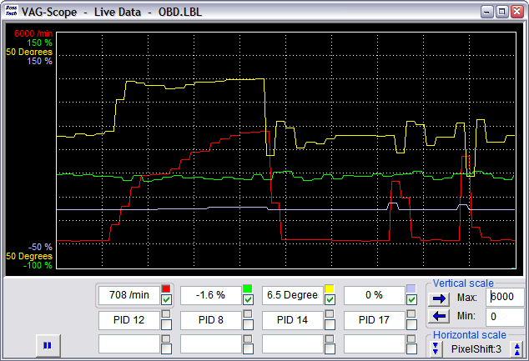

VAG-COM - Applications

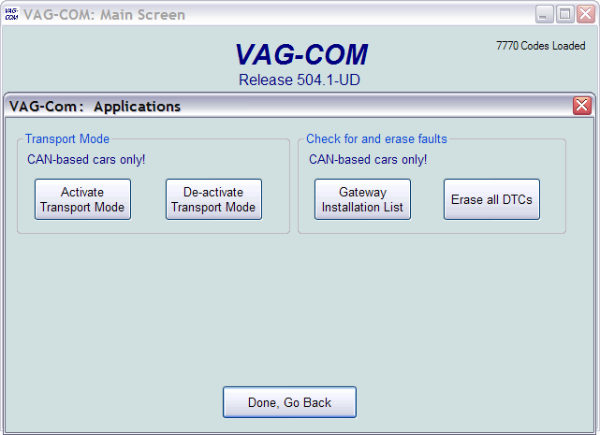

Transport Mode
On vehicles using CAN for diagnostics, there is a special Transport Mode that is used by the factory to put the cars into a "sleep" to conserve battery charge during long periods of inactivity. These functions only work on Golf V based cars.
[Activate Transport Mode]
Clicking this button will put applicable vehicles into Transport Mode, shutting down most systems.
[De-activate Transport Mode]
Clicking this button will "wake up" applicable vehicles from Transport Mode, powering up most system.

In the B7 Audi A4, Transport Mode works a little differently. To take the car out of transport mode, go into

[Select]
[17 Instruments]
[Adaptation - 10]
Enter channel 99
Put in a new value of 0
[Test]
[Save]
Applications cont.
Check for and erase faults
[Gateway Installation List]
Usually available only on Gateways in cars using a direct CAN connection for diagnostics (like the new A8 and all Golf-5 chassis cars). This very fast function takes about 3 seconds to query the car's Gateway to find out what modules are installed in the car and what their status is. Any modules having fault codes should show a "Malfunction". Modules are directly accessible from this screen by double clicking on the appropriate line. The following screen-shot is from a Golf-5 in Europe:

[Erase All DTC’s]
On vehicles using CAN-Bus for diagnostics, VAG-COM clears all of the fault codes in all control modules in the car without accessing all the control modules individually.

VAG-COM - Options Screen

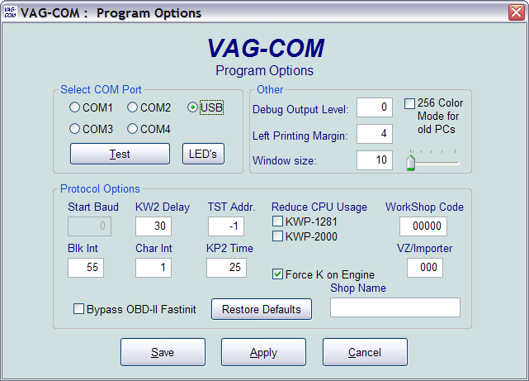
On this screen you can set a number of Options and must be used the first time you use VAG-COM on a PC.
Select Com Port
Set the COM Port to which you have connected the Interface Adapter.
You can then click [Test] to see if VAG-COM can find the adapter. For more information see the Table of Contents for the page listing for Getting Started.
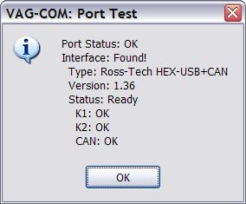
The [LED’s] button is useful for testing a port's outputs with the Interfaces that have LED's.
Options Screen cont.
Debug Output Level
A zero in this field (the default) means NO debug output will be generated whatsoever. This should decrease VAG-COM's susceptibility to interference by things like virus scanners (except when logging data). To generate Debug Output, put a number in this field. The number should of a reasonable size, such as 100. Small numbers will generate very little information. Debug should only be used if you are asked to do so by Ross-Tech.
Left Margin Printing
This is the number of spaces that printed pages are shifted to the right.
Window Size
This function allows you to change the apparent size of the VAG-COM window on your screen. Adjust this in small increments since it is possible to make VAG-COM so large that it is much bigger than your screen! To see the resizing take effect, do a Test and Save, then close VAG-COM. When you restart, the new window size should be shown.

Color Scheme
This display mode changes the background color from blue to white, and looks better on some older monitors. The change will take effect after you close and restart VAG-COM.
Protocol Options:
- Start Baud is the first baud rate that VAG-COM will try when connecting to a controller. The current default value is 0. This means VAG-COM will determine the correct start baud on its own. With the HEX Interfaces, this field is unavailable.
- KW2 Delay has to do with the amount of time used during the initialization of a session between the PC and the car. The current default value is 30. Do not change this value from the default unless you are having difficulties communicating with a particular controller. Contact us for advice if you are.
- TST Addr. has to do with the packet addresses used by KWP-2000. The current default value is -1. Do not change this value from the default unless you are having difficulties communicating with a particular controller. Contact us for advice if you are.
- Blk Int affects the protocol timing. The current default value is 55. To get the highest sample rate possible in the Measuring Blocks screen, set this to 25. Note, however, that this may cause unreliable communications with some controllers.
- Char lnt also affects the protocol timing. The current default value is 1. To get the highest sample rate possible in the Measuring Blocks screen, set this to 0. Note, however, that this may cause unreliable communications with some controllers.
- The KP2 Time parameter only applies to controllers using the KWP-2000 protocol. The current default value is 55. Decreasing it increases the sample rate in Measuring Blocks on control modules that use the KWP-2000 protocols. The default value should be safe for all applications, but if it's not, you can always increase it again (to a maximum of 99).
Options Screen cont.
- Using the Reduce CPU Usage checkboxes will greatly increase responsiveness of other apps running at the same time as VAG-COM. The disadvantage is somewhat reduced sample rate.
- KWP-1281: The default value is unchecked. This reduces CPU usage when connected to controllers using KWP-1281. Using this feature *may* make the session with some control modules unreliable.
- KWP-2000: The default value is unchecked. This reduces CPU usage when connected to controllers using KWP-2000.
- Force K on Engine is used on controllers that use the CAN-Bus for diagnostics. This box is checked by default since the K-line often delivers faster sample rates while datalogging than does the CAN-Bus.
- Bypass OBD-II Fastinit should only be checked if you are experiencing difficulty connecting to a vehicle using generic OBD-II.
- The Work Shop Code (known as the WSC) is found on the Admin screen of a dealer's VAS-5051, as well as on the dealer's stamp. The default value is 00000. For example, using the stamp below, the dealer's number is 401/742. To derive the Work Shop Code, drop the first digit and use the remaining digits in order.

So, Evergreen Terrace Volkswagen has a WSC of 01742. This only applies to US VW dealers. Canadian dealerships use a 4-digit number on their stamp. To find the WSC, place a 9 before their number.
- The VZ/Importer number is essentially a "region code" extension to the Work Shop Code (should be 444 for US, 999 for Canada). The default value is 000. If you are an individual user or independent mechanic, just leave the WorkShop Code set to "0000" and VZ/Importer number set to "000". This allows VAG-COM to operate in “stealth” mode, keeping whatever WSC and Importer numbers that were already in the controller. If you are using VAG-COM at a Dealership, enter your Dealer's Workshop Code and VZ/Importer number. VZ/Importer number and Work Shop Code are not easily changed once set on this screen. Contact us for advice if you need to do so.
- Shop Name is displayed on reports, such as the Fault Code Report.
Options Screen cont.
[Restore Defaults] will reset all Protocol Options (except WorkShop Code and VZ/Importer number) to their "as-delivered" settings.
The KP2 Time parameter only applies to controllers using the KWP-2000 protocol. The current default value is 55. Decreasing it increases the sample rate in Measuring Blocks on control modules that use the KWP-2000 protocols. The default value should be safe for all applications, but if it's not, you can always increase it again (to a maximum of 99).

[Save] causes the current options to be stored. You need to Save the first time you use VAG-COM on a PC.
[Apply] lets you use and test the options without storing them.
[Cancel] takes you back to the Main Screen without any effect.

VAG-COM - About Screen

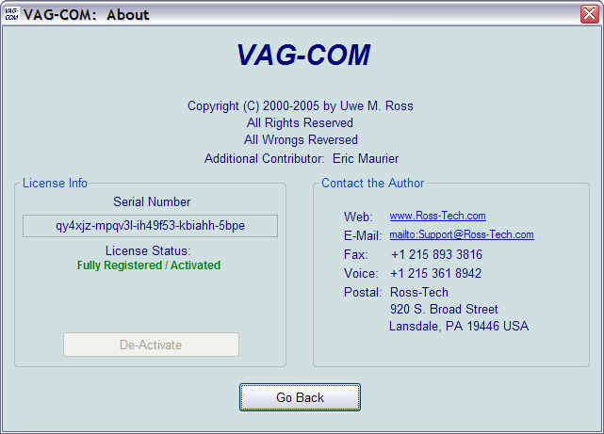
License Info
- The Serial Number will initially be “Please test on car before registering” until you have connected to a car and checked fault codes in a controller. After you have done this, you will have a Serial Number composed of letters and numbers.
- License Status should always be Fully Registered / Activated, since all of our Current Interfaces have activation built-in.
On this screen, you will also find a Copyright Notice, License info, and Contact Information. The Web and E-Mail "links" open up your browser or mail program, respectively and can be used if your PC is connected to the Internet.
To return to the Main Screen, click [Go Back].

Appendix A: VAG-COM Problems & Issues
Possible Issues, all versions:
- We have some reports indicating that VAG-COM versions 211.1 and newer do not get along with the Zone Alarm firewall application. If you are using Zone Alarm, turn it off while using VAG-COM.
- SP1 (Sevice Pack 1) for Windows 2000 adversely affects VAG-COM's ability to do real-time and makes communications with some controllers unreliable. If using Windows 2000 with Service Pak 1, you should apply Service Pak 2 or Service Pak 3.

1997 VW Passat B5 Central Convenience System
These controllers seem to have a bug that causes them to drop the communications session when VAG-COM requests the door-slave controller "Extra" info. A work-around is available in Version 0.70e which simply does not request any "Extra" info. If you have a 1997 B5 Passat (non-US models only), use 0.70e on the Central Convenience system. 1998 and newer Passats do not have this problem.

1990-1993 VW Cabrio/Cabriolet Airbags
These controllers do not communicate with VAG-COM. In fact, they do not communicate with Volkswagen's VAG-1552 scan tool either, unless the 1552 has an old, outdated program card installed.
Audi
Concert and Symphony Radios
These are made by Matsushita. The Concerts have blatant bugs in the diagnostic protocols. We've added one work-around to the low level protocol drivers that works in some, but not all Concerts, and it is not 100% reliable in any case.
Some Concerts occasionally get "stuck" in an undesirable mode after attempting communications. If your Concert gets "stuck", the way to reset it is to remove all power from from the radio for at least 10-15 seconds. This can be done by:
- Removing the radio from the car.
- Disconnecting the car's battery
- Pulling the fuse for the radio.
Note: Some radios will require you to enter the "security code" using the radio's front panel after loosing power. See the your owner's manual for the radio for instructions.
It appears that there is something not quite up to snuff in the Symphony's ability to drive the K-line. We've had some reports that they work better with non-optically isolated interfaces, and they may work better with the engine running (which means there is a higher voltage on the VBatt lines in the car).
Appendix A: Problems/Issues cont.
1994-1997 Audi C4 (A6/S6) Instrument Clusters
These have a high bit-error rate. We suspect they use a software-UART and "stretch" bits sometimes. The error-detection/correction logic built into VAG-COM's low-level protocol drivers as of version 0.70 seems to take care of this in a majority of cases, but I still had few reports of customers not being able to communicate with these clusters. In version 0.75 or or newer, please ensure that Char Int on the Options Screen is set to approximately 3 (which is the default). On some PC's, it may be necessary to adjust this value to something other than 3. On very fast PC's try a higher value. On very slow PC's, try something less.

1996-1997 Audi A6 2.8L 12V V6 Engine
There is a bug in the Hitachi ECU that does not allow reliable monitoring or logging of multiple measuring groups. For these vehicles, we recommend only viewing or logging one group at a time.
2003+ 01J (CVT) Transmissions
These have rather unusual timing requirements. When used with a HEX-COM or HEX-USB, increase Char Int on the Options Screen to approximately 4 or 5.

Appendix B: VAG-COM
Frequently Asked Questions FAQ
1.1: Will VAG-COM work with my car?
VAG-COM will work with most Volkswagen and Audi models sold World-Wide 1994 through 2006. It will work with some cars all the way back to model year 1990. It will also work with most late-model SEAT, and Skoda models sold in markets other than North America. If your VW or Audi has a 16-pin "OBD-II style" Data Link Connector, VAG-COM will definitely work. If your car has the old "2x2" Data Link Connection, check if there is a wire going to each pin. If there are four wires, VAG-COM should work. If there are only three, it won't.
Please see these Application Charts at:
www.Ross-Tech.com/vag-com/cars/applications/ where you can select your model and see which modules can communicate with VAG-COM. Also see the Issues page for a few things that may not work as expected. If in doubt, e-mail us.
1.2: Q: Will VAG-COM work even if my car is "chipped"?
Yes. If it doesn't work in a "chipped" car, the chip-vendor did something seriously wrong! Chips from reputable vendors are fully VAG-1551 (and VAG-COM) compliant.
1.3: Q: What functions are included in the current release?
VAG-COM is a software program that turns your PC into sophisticated VW/Audi diagnostic tool, which performs the functions of a factory VAG-1551 or VAG-1552 scan tool. Please see the Function Chart in Appendix E for the current feature set.
1.4: Q: What are the computer requirements?
A PC running Windows: We recommend at least a Pentium-100 (or AMD equivalent) with 16MB of RAM and Windows 95 or newer. VAG-COM may work on some lesser PC's, but anything less than the above recommendation is unsupported. Windows 95, 98, ME, NT4, 2000, and XP are all fine. Available disk-space should be a non-issue, VAG-COM requires less than 10 MB. If you are using a power supply for a laptop, it should be one specifically designed for that purpose, NOT a "universal" adapter.
To use one of our Serial Interfaces, the PC must have an available RS-232 Serial port! Otherwise, you'll need to choose one of our USB Interfaces.
A RS-232 Serial Port looks like this:
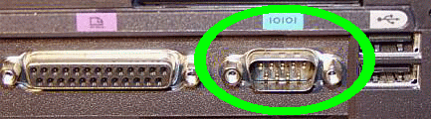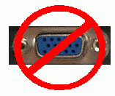
Observe the port we surrounded with the GREEN oval. Notice the 9 MALE pins? That is a SERIAL port and WILL work! Observe the port circled and crossed in RED. Notice the 15 FEMALE pins? That is a MONITOR port and will NOT work!
1.5: What if my Laptop doesn't have a Serial Port?
Contact Ross-Tech. We offer our own USB Interfaces which use the USB port on your PC, rather than the Serial Port. USB<->RS232 converters are "Not Supported."
Appendix B: VAG-COM FAQ cont.

1.6: What if the PC I wish to use with VAG-COM doesn't have Internet access?
To update VAG-COM, you’ll need to download and install the latest version from our website. Because our updates are provided to you via our download page, rather than on floppy disks or CD's, you will need a way to transfer the Self-Installing EXE file to the PC that you will be using with VAG-COM. The file fits easily on a floppy disk and can also be burned onto a CD-R or CD-RW. Make sure that you do not run the EXE file until you have copied it onto the PC where you would like VAG-COM to be installed. You do not need to be connected to the Internet while using VAG-COM.
1.7: Can I use VAG-COM on a desk-top computer?
Yes, use the Serial (DB9M to DB9F) extension cord included with your kit to extend up to 25 ft. You can extend an additional 25 ft. by purchasing a second Serial Extension Cable.
1.8: Will there be a Mac or Linux version?
There will be no "native" Mac or Linux versions. The time and effort required to "port" VAG-COM to these platforms would never be worthwhile. One person has gotten VAG-COM running under Linux using WINE and another person has managed to get VAG-COM working on a MAC with Virtual PC. Neither of those examples are supported by Ross-Tech.

1.9: Will there be a Windows-CE/PocketPC/WindowsMobile or Palm-OS version?
Possibly at some point in the future, but we don't have a timetable yet. We conducted a poll of current and potential VAG-COM users about where we should concentrate development efforts. The results:
75 % Improving and adding features to the Windows version
11 % Porting VAG-COM to Windows CE / PocketPC
9 % Porting VAG-COM to Palm
3 % Porting VAG-COM to LINUX
2 % Porting VAG-COM to Macintosh
Some of our customers use VAG-COM on a tablet PC such as a Fujitsu Stylistic or on an ultra-portable PC such as a Toshiba Libretto. These can be purchased inexpensively on auction sites. These REAL PC's work wonderfully and have very small form factors (the Libretto is about the size of a VHS video cassette).

1.10: What's the difference between VAG-COM and an OBD-II Scan-Tool?
OBD-II is a government mandated diagnostic protocol that is primarily aimed at diagnosing emissions-related problems. An OBD-II scan tool will work in many different brands of cars. VAG-COM uses VW's proprietary diagnostic protocol and will only work in VW/Audi vehicles. Although you can use an OBD-II Scan Tool in an OBD-II compliant (1996 or newer) VW or Audi, an OBD-II Scan Tool can only talk to the engine, not the numerous other "intelligent" systems in the car. Want to reprogram your central locks or your Radio? Diagnose a problem with your ABS, Airbags, or Automatic Transmission? Re-align your Immobilizer after swapping ECU's? Reset your Service Reminder Indicators? Communicate with a pre-1996 model (not OBD-II compliant) car? An OBD-II Scan-Tool can't do any of these things. Our latest version of VAG-COM adds Generic OBD-II functionality, for more information see the Table of Contents for the page listing for OBD-II.
1.11: Can I use VAG-COM to roll back my electronic odometer?
A: No. A brand new instrument cluster (with less than 100 km on it) can be rolled forward, one time only. Of course, this assumes that the instrument cluster is "diagnostics capable". Not all instrument clusters with electronic odometers are.
Appendix B: VAG-COM FAQ cont.
1.12: Can I use VAG-COM to "Flash" the chip in my ECU?
No, we have investigated flashing, but found that there are several different methods of encryption for various VW/Audi vehicles, as well as delicate licensing issues to overcome. Therefore, we do not intend to pursue flashing any further at this time. You cannot alter boost, timing, fueling, rev limiter, or speed limiter with VAG-COM. You should contact a chiptuner if you wish to have those parameters altered.
1.13: Is there anything else I need to make full use of VAG-COM?
Yes. A good Factory Repair Manual containing the VAG Scan-Tool procedures for your car. VAG-COM is a tool, not an on-line service manual. We could not possibly document everything you can do with it in every year and model of VW/Audi that VAG-COM can be used with. The most cost-effective manuals with good Scan-Tool procedures for US/Canadian vehicles are the CD-ROMs from Robert Bentley Publishers. We offer these at a discount to registered VAG-COM users. Beware, however, that many of the paper "Service Manuals" published by Bentley do not contain Scan-Tool Procedures. If a paper Bentley manual is called a "Service Manual" it usually does not have scan-tool procedures. If it is called "Official Factory Repair Manual", it does. An additional source of manuals that contain Scan-Tool procedures is Dyment Distribution Services (1-800-544-8021).
Since the above Bentley Factory information only applies to US/Canadian vehicles, if your car is European-spec or from the rest of the World, they may be of little use to you.
For Rest-of-World VW manuals, check erWin.volkswagen.de
For Rest-of-World Audi manuals, check erWin.audi.de
For Rest-of-World Seat manuals, check erWin.seat.com
For Rest-of-World Skoda manuals, check skoda-haendlershop.de (German-only)

2.1: How do I Register/Activate my software?
All of our Current Interfaces have Activation built-in, so VAG-COM should always be Fully Activated once it has been tested on a car.
2.2 What's the difference between the Shareware version and the fully registered version?
When you first download a new version of VAG-COM from our website. it operates in a limited Shareware mode until you plug in the Interface and test it on a car.

2.3: Is Product Support included in the price?
A: Absolutely. If you have a question or problem, please post it to the VAG-COM mailing list, mail it to us directly, or give us a call. However, please understand that we don't know everything about every VW/Audi ever made.

2.4 Why can't I get VAG-COM to communicate at all?
Check the following:
- Is the adapter plugged into the car? A Serial Interface that is not plugged into the car will always be "Not Found". It gets power from the car!
- Is the car's ignition switch in the ON position?
- Is it plugged into the correct serial port? Some PC's have the ports mis-labeled.
- Are the serial ports on your PC properly configured?
Appendix B: VAG-COM FAQ cont.
2.4 Why can't I get VAG-COM to communicate at all? Cont.
- Disable Palm HotSync or Microsoft ActiveSync software!
- If you have a 1997 or newer car with an aftermarket radio or if you have used your ISO-COM Interface on a car with an aftermarket radio, read this page:
http://www.ross-tech.com/vag-com/aftermarket-radio.html
- Check our Issues page for any special configuration settings that may be necessary for your vehicle
- If you are using a power supply for a laptop, it should be one specifically designed for that purpose, NOT a "universal" adapter.
Note: If you test the COM port, but an hourglass appears, you may have an IRQ conflict. This may not show up in Device Manager as a conflict. But, try this:
- Start>Run>MSINFO32.EXE to bring up the System Information utility.
- Go to Hardware Resources>IRQs This should show a list of all devices by their IRQ, so you can see if there are any repeated or shared IRQs.
If all else fails, feel free to call or email us, making sure to provide the brand and model of vehicle, brand and model of PC, and version of VAG-COM.
2.5 VAG-COM communicates, but it's "flaky".
The diagnostic protocols require a degree of real-time response from the diagnostic tool. Certain other programs and services can prevent VAG-COM from responding in the timely fashion that the protocols require. Some control modules are fussier about this than others.
Fixes:
Make sure you are using the latest version of VAG-COM. If you have any other programs running, close them. If you have any of the following active on your computer, turn them off:
- Virus Scanners
- Task Scheduler
- Microsoft Active-Synch
- Fast-Find
- Some Novell Netware network drivers
- Canon "Multipass" multi-function printer/scanner software
- Power Management -- some laptops are notoriously difficult, try running the laptop on AC power!
Other Tips:
- Go through all the stuff in your System Tray:
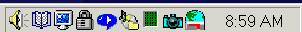
Right-Click on each little icon. If there's a "Disable" or "Exit" option, do it!
- Windows 2000 with SP1: Install IE 5.5 or SP2.
- Windows 95/98/Me: Pull up a task list by pressing CTRL-ALT-DEL. Kill everything except Explorer and Systray.
Appendix B: VAG-COM FAQ cont.

2.5 VAG-COM communicates, but it's "flaky". Cont.
- All versions of Windows: Start -> Run -> MSCONFIG. Take a look at what other non-essential stuff Windows is loading and disable it.
- STOP or remove PCMCIA Cards, especially anything made by Xircom. Some IBM brand cards are also problematical.
- Try turning Off your COM Port's FIFO buffers. Open the properties sheet for the COM Port in Device Manager. Select the Port Settings tab. Click the Advanced button. Uncheck the "use FIFO buffer" checkbox.
- Some Windows installations, especially ones that have had numerous program installed and uninstalled over the years may be hopeless. Try installing a clean copy of Windows in a different folder than the original.
- If you have an older, slower PC running Windows XP, try setting the Display Properties>Appearance to Windows Classic Style instead of Windows XP Style.
- If you are using a USB Interface, go to Device Manager, USB Root Hub, Properties, Power Managment, and uncheck "Allow Windows to turn off this device to save power"
If all else fails, feel free to call or email us, making sure to provide the brand and model of vehicle, brand and model of PC, and version of VAG-COM.
2.6 Why does my dash BEEP when I access my ABS controller?
In many of the newer models, there will be a series of BEEPs from the dash when you access the ABS controller (and the ABS light will be ON while you are talking to it). This perfectly normal and is done to notify the driver that the ABS is non-functional while in diagnostic mode.
2.7 Are there any Fault-Codes that can and should be ignored?
Yes. Most 1995 and earlier Bosch ECU's will show you a DTC 00513 - Engine Speed Sensor (G28) if you scan them when the engine is not running. This fault code goes away by itself once you start the engine. If this sensor were truly defective, the engine would not run at all! Please ignore this code. In addition, many Automatic Transmission Control Modules will show a DTC 00526 or 17087 that indicates a faulty brake light switch. This can also be ignored and will not appear if you press the brakes once before checking for Fault Codes.
2.8 Are there any known Bugs / Problems / Issues?
Please check the Revision History Page and Issues Page.
2.9 What's the Work Shop Code?
Every VW/Audi dealer in the world is assigned a unique Work Shop Code. A brand-new factory VAG-1551/1552 or VAS-5051/5052 scan tool will not function until a WSC is entered, and once it has been entered, it cannot be changed. Whenever a Control Module is Re-Coded, or certain Adaptations are performed, the scan tool sends its WSC to the control module and the control module records it for posterity. Thus, if a scan-tool is used to do something like disable certain airbags, in principle, it should be possible to tell who (which dealer) did that. Like the factory scan-tools, VAG-COM will accept a WSC once on the Options Screen. If you enter a WSC there, it will be sent to the control modules exactly like it's supposed to be. If you leave the WSC on the Options Screen at it's default of 00000, VAG-COM will operate in "stealth mode". Instead of sending a fixed WSC, it will put back whatever was already in the control module, with one exception: If it finds the "telltale" WSC (30011) that VWTool/VDS-PRO likes to leave behind, VAG-COM will replace it with something more innocuous.
Appendix B: VAG-COM FAQ cont.
2.10 What's with the DEBUG files?
VAG-COM uses these to record a lot of the data being exchanged between the car and your PC. Having these can be very useful if there is some sort of unexpected problem communicating with a controller in your car. By default, the Debug Level is set to 0. If you're having a problem, we may ask you to set the Debug level to something other than zero, and to send us a specific Debug file. The best way to send Debug files is to ZIP them first.
3.1 Do I need an Interface Adapter?
Yes. The ISO-9141 port in your car is not directly compatible with any standard PC port. The ISO-9141 port in your car is somewhat RS-232 like, but you can't just wire up a cable -- you must put electronics in between to allow a PC to communicate with the car.
3.2 Can I use an Interface adapter that came with another software package?
Yes, to a limited extent. Any interface adapter that works with VWTool or VDS-PRO should work with Release 311.2 or older versions of VAG-COM. In addition, the ISO-only interface adapter that Alex Peper ships with his Vehicle Explorer OBD-II software package will work. Alex's "combination" adapters will not work with VAG-COM. Most other "OBD-II" adapters will not work. Lastly, the interface adapters supplied with the German Posicon software that many VW and Audi OTS's have access to will work. The VAS-6103 cable that should now be in the workshop at every VW/Audi dealership works with most control modules in most cars, but won't work with some ECUs. If you have some other adapter, simply try it, you can't hurt anything. Of course, if you have difficulties using VAG-COM with that adapter, you'll need to contact the hardware supplier for support. Compatibility of future versions of VAG-COM with 3rd party interfaces is not guaranteed.
3.3 Can I buy an Interface adapter somewhere else?
Yes. You may find vendors that are willing to sell compatible interface adapters without any software license. We have no problem with that. Once you're up and running, you can register your VAG-COM software with us for $99, but please don't expect start-up support from us if you can't get it working. We cannot provide support for 3rd party hardware. We have reports that some 3rd party Interfaces do not work correctly with some controllers. We will not provide either hardware or software support for you unless you are our customer. If you buy someone else's interface and can't get it working, contact your vendor for support! Of course if you buy one of our complete hardware/software kits, we will provide start-up support as well as free updates for at least one year from date of purchase. Compatibility of future versions of VAG-COM with 3rd party interfaces is not guaranteed.
3.4 Can I build my own Interface Adapter?
Yes. There are a number of websites with plans and schematics. However, we will not provide links to them, nor do we sell connectors or parts. We do not have the time or inclination to help people debug their home-built interface adapters via e-mail or over the telephone. If you choose to build your own adapter, that's fine -- we have no problem with that. Just don't expect any assistance from us until you have VAG-COM talking to your car in shareware mode. We have reports that some 3rd party Interface designs do not work correctly with some controllers, Once you've got it working, you can register the software for $99 and get full support for the software. Of course if you buy one of our complete hardware/software kits, we will provide start-up support as well as free updates for at least one year from date of purchase. Compatibility of future versions of VAG-COM with 3rd party interfaces is not guaranteed.
Appendix B: VAG-COM FAQ cont.
3.5 Why does VAG-COM require Activation?
All of our Current Interfaces have Activation built-in so users never have to worry about Activation, De-Activation, etc. However, VAG-COM versions prior to 5xx.x will also run through "dumb" interfaces, which are not particularly difficult to make and we would like to get paid for our work! The reality is that there many people in this world that just won't pay for software unless they have to. We've invested a large amount of time and expense into reverse-engineering the VAG protocols, and we're trying to make a living with this product. Further more, we're trying to sell it at a price that makes it affordable to everyone. The activation scheme is intended to ensure that we get paid by every user, not to make life difficult for registered customers.
3.6 What if I need to run VAG-COM on more than one PC?
All of our current Interfaces have Activation built-in, so you can download and install VAG-COM onto as many PC's as you'd like, so VAG-COM is fully Registered and Activated once you test it on a car.
3.7 How do I permanently move VAG-COM from one PC to another?
All of our current Interfaces have Activation built-in, so you can download and install VAG-COM onto as many PC's as you'd like, so VAG-COM is fully Registered and Activated once you test it on a car.
3.8 What's the De-Activate button for? Why would I want to do that?
All of our Current Interfaces have Activation built-in, so there is neither a need nor a choice to De-Activate.
3.9 Why has VAG-COM become De-Activated on its own?
All of our Current Interfaces have Activation built-in, so VAG-COM should always be Fully Activated once it has been tested on a car. If you have a Current Interface and VAG-COM has become De-Activated, please contact us
3.10 Can I sell my VAG-COM System to someone else?
You can sell the hardware, but the software license and support are not transferable. All of our Current Interfaces act as "dongles" for VAG-COM, so the software should be fully functional on any PC that meets our requirements. However, we only provide support to the original purchaser. If you purchase a second-hand "dongle" Interface and want to be a "registered user" and get technical support, you'll still need to pay $99 to register.
4.1 Why and How should I test VAG-COM prior to Activating it?
All of our Current Interfaces that have built-in Activation, are fully Registered and Activated once you test them on a car. With these Interfaces, the license is built in, you do not have to Activate VAG-COM, but obviously you'll want to test VAG-COM when you get it to make sure everything works properly. First, Download and install VAG-COM on your PC. Find your vehicle on the Applications Page to see which control modules are in your car. Connect your Interface to your car's Diagnostic Port and to your PC. Turn the ignition ON (turn the key so the Instrument Cluster lights up, but do not start the car -OR- start the car). Go into the Options screen, select the correct port, and click the TEST button. Ensure that VAG-COM finds your interface, you should see a message that says Interface Found. Now click SAVE. Select one of your car's Control Modules (note: your car will not have all the Control Modules listed in VAG-COM, only the ones on your Applications Page). After VAG-COM has Connected, check Fault Codes. Repeat the process for each of your car's Control Modules. If you encounter problems, please try These Suggestions first. If you still have problems, feel free to Contact Us with full details about your PC and vehicle, preferably while you are in front of both.
Appendix B: VAG-COM FAQ cont.
4.2 Can I use VAG-COM while I am driving?
We strongly recommend against reading data while driving -- that would be an accident waiting to happen. Almost everything that changes while you drive can be LOGGED to a .CSV file, which you can analyze to your heart's content using VAG-Scope or Excel (or a number of other programs) preferably while the vehicle is not in motion..:-) If you find it necessary to read data while the vehicle is in motion, we strongly urge you to use a second person -- one to drive, one to look at the PC. This second person should sit in the back seat, because a laptop used in the front passenger's seat becomes potentially lethal if an airbag drives it back into the passenger's head or torso in case of an accident.
4.3 What is "The Aftermarket Radio Problem"?
If you are working on a 1997 or newer car with an aftermarket radio read this page:
http://www.ross-tech.com/vag-com/aftermarket-radio.html
4.4 How do I upgrade my existing VAG-COM software to the newest version?
You should be able to simply Download and install the latest release of VAG-COM in your PC. All of our Current Interfaces have built-in Activation, so the new version should be fully Registered and Activated once you test on a car. If you'd like to be notified when a new version of VAG-COM becomes available, you should sign up for our Announcements List.
If you purchase a genuine Ross-Tech Interface directly from us, or from one of our Distributors, you are entitled to free software updates for at least one year from date of purchase.
4.5 What is the purpose of the "OBD-II" button? Why would I want to press it?
See the OBD-II Page for more information. You can use this test to determine whether a car is ISO/OBD-II compatible, i.e. whether it "speaks" the OBD-II protocols, if the car uses the ISO-9141 hardware layer for OBD-II. This has nothing to do with the VAG protocol that VW uses, and the results of this test have nothing to do with VAG-COM working with any VW/Audi/SEAT/Skoda vehicle. No VW or Audi products prior to model year 1996 are OBD-II compliant! Please note that most vehicles sold outside of the US are NOT OBD-II compatible, and even some US-market TDI's are not OBD-II compatible.
4.6 How do I print screens or data in VAG-COM?
You can print reports from VAG-COM's Fault Code, Auto-Scan, Control Module Finder, and Gateway Installation screens. You can save data to a Log file and print using a spreadsheet program. To print screens, we highly recommend the HardCopy (freeware) program.
4.7 What are Label Files?
In Measuring Blocks, Basic Settings, Adaptation, or Recode, VAG-COM tries to elaborate as much as possible what the data means. Unfortunately, the "Data Type" information coming from the Control Module is not that precise. For example: VAG-COM can tell that a particular field contains a Temperature, but the data from the Controller doesn't tell us whether this is the Coolant Temperature or the Intake Air Temperature.
To reduce the confusion, VAG-COM supports Label Files and which provide more information about the data being displayed in Measuring Blocks and can also provide additional information for the Coding function and Adaptation Channels. When a Label file for the Control Module you are looking at does not exist, VAG-COM will base the elaboration is based on an "educated guess" what a particular Data Type means.
Appendix B: VAG-COM FAQ cont.
4.8 How can I speed up my sample rate in VAG-COM?
The sample rate at which you can view and log data is largely determined by each controller in the car. There are a few things you can do to speed up the rate for a given controller. First, logging one group at a time, rather than two or three, will help greatly. In order to get the highest sample rate possible go to the Options screen and set Blk Int to 25 and Char Int to 0. Note, however, that this may cause unreliable communications with some controllers. The KP2 Time parameter only applies to controllers using the KWP-2000 protocol. Decreasing it speeds up the sample rate in Measuring Blocks on control modules that use the KWP-2000 protocols. Try setting it to 0. If any of these adjustments cause unreliable communications, change them back closer to the defaults. If in doubt, use the Restore Defaults button! In Engine controllers using KWP-2000, there is a [Turbo] button in the latest version of VAG-COM. This can significantly speed up sampling, in some cases to over 30 samples per second. See the Measuring Blocks page for more information.
4.9 What kinds of cool stuff can I do with VAG-COM? See our Car Info & Procedures Page where you can look up Vehicle Specific Application Charts for your car to see which control modules exist and can communicate with VAG-COM. Additionally, there are some very useful links to pages about Key Matching, Immobilizers, as well as some excellent spreadsheets submitted by our customers.
http://www.ross-tech.com/vag-com/cars/index.html
4.10 How do I set up my USB Interface?
To use one of our USB Interfaces, you'll need to download and install the latest version VAG-COM with USB Support. After you have installed VAG-COM, you will need to follow the instructions on the USB driver installation page.
4.11 Does Ross-Tech make diagnostic software for other makes of cars?
Currently, we sell only VAG-COM, which works on VW/Audi/SEAT/Skoda. We are developing diagnostic software for BMW/MINI vehicles, but are in the very early development stages. Specification, functions, pricing, and release date information for the new product are not yet available. We do not currently have plans to develop software for any other makes of cars, but of course, all plans are subject to change. If you'd like to add generic OBD-II functionality for Chrysler/Imports to your existing Serial Interface, see our OBD-II page for information about 3rd party software. We do not know of any other makers of similar software for other makes of vehicles. Our latest Version of VAG-COM adds Generic OBD-II functionality, see the OBD-II Page for more info.
4.12 Can I use VAG-COM to retrieve my Radio Code to get it out of "SAFE" mode?
No, You'll need to get the radio code from your dealer (it should also be on a card that came with your car). Most likely, the dealer will need to physically remove the radio to read its chassis number, then the chassis number is input into a database at the dealership to retrieve the radio code. Neither VAG-COM nor the factory scan tools can retrieve the radio code for you.
4.13 Does VAG-COM work with cars that require direct CAN access for diagnostics?
Yes! We have integrated CAN compatibility into the latest version of VAG-COM, but since CAN uses different hardware, new interfaces are required. These are now available as well. The new HEX-COM+CAN and HEX-USB+CAN interfaces are fully compatible with the new latest cars which require a direct CAN connection.
Appendix B: VAG-COM FAQ cont.
4.14 Can I use VAG-COM to make my windows roll up and down using my keyfob remote?
Many Audi vehicles can be recoded to allow this function, see this example. Unfortunately, VW models do not have the same capability. In order to make your windows roll up and down using your remote in a VW, you'll need to add extra hardware such as the Remote Window Controller from Alientech:
http://www.alientech.net
4.15 How do I obtain an SKC for Immobilizer and Key-Matching functions?
We do not know of any way to retrieve an SKC for VW/Audi/SEAT/Skoda vehicles other than getting it from an official dealership. Prior to 2002, some vehicles were delivered with a 4-digit SKC on a scratch-off panel on a plastic tag. Starting in 2002, dealerships implemented the WIN2 system to provide 7-digit SKC's to their technicians and customers. Recently, many dealerships have switched to the new GEKO system, whereby their factory scan tools dial up the factory while connected to a car. Under this system, the technician no longer sees the SKC at all. VAG-COM does not interact with the GEKO system.

Appendix C: VAG-Scope
Graphing "Plug-In" for VAG-COM
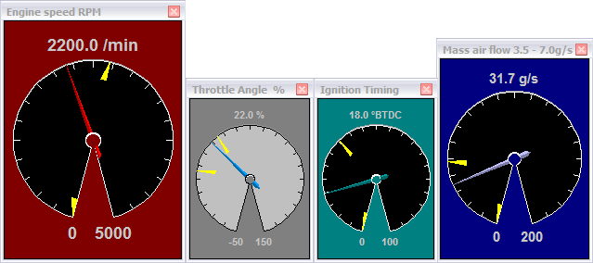
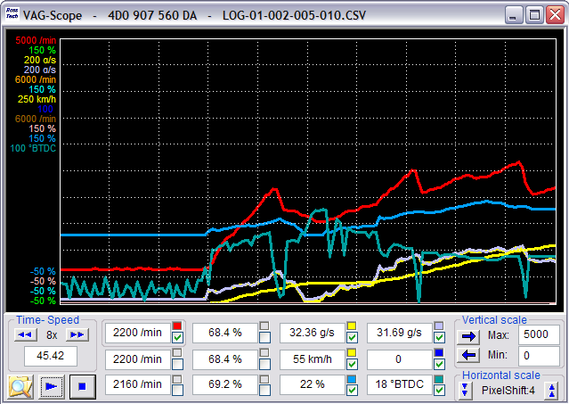

Appendix C: VAG-Scope cont.
Quick Instructions:
- You can use VAG-Scope in one of two ways: Allow VAG-COM to launch VAG-Scope by clicking the [VAG-Scope] button on the Measuring Blocks screen, or manually start VAG-Scope in stand-alone mode to play back VAG-COM Log Files. You cannot do both at the same time. If VAG-Scope is running in Stand-alone mode, VAG-COM will not start. If you manually start VAG-Scope while VAG-COM is running, it will probably complain.
- Use the checkboxes next to each display field to select which items are graphed.
- Click on a field to select it for vertical scaling. VagScope will remember all scaling values for a particular control module by part number.

- Click the Ross-Tech Icon for a menu item to access a Preferences Dialog:

Preferences:
- Here you can set colors for the graph lines, the graph background and the grid.
- You can also set default scaling values (based on the units that VAG-COM sends)
NOTE:
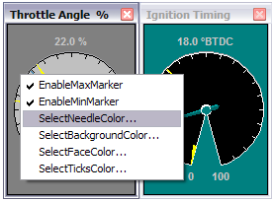
VAG-Scope can be used to play back Log files produced by any version of VAG-COM. Using it to graph live data in real-time requires VAG-COM Release 303.1 or newer.
VAG-Scope included in the latest VAG-COM release on our Download page.
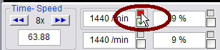
Right-click on the color box to open up a gauge for that value.

Appendix C: VAG-Scope cont.
VAG-Scope -- FAQ:
Q: What are those numbers on the left of the graph?
A: They are the scaling numbers. They define the min and max values that will be graphed in the window. For instance, a temperature could be graphed between -10 and 130*C.
Q: Great, but I don't like the current ones.
A: Don't worry, everything is fully customizable. You have two different ways of choosing your scaling factors:
- In the preferences screen, you can either modify the values for an existing units, or add a new unit with its values. Make sure the unit is spelled exactly (including the case) as it appears in the measuring blocks/graphing data.
- In the main screen, click on a field (or use the blue horizontal arrow) to display its scaling values. The field you're working on is surrounded by a frame. You can then change the min and max scaling factors for this particular field
- Both settings are saved, so that next time you won't have to do it all over again!
Q: So what's the difference between these two different ways?
A: First, you need to understand how the values are stored/retrieved. When Vag-Scope graphs data from a controller it doesn't know, it applies the values in the preferences screen, for the units that are defined. If a unit is "unknown", the min will be 0 and the max will be 100.
Setting the values in the main screen allows you to override these defaults. For instance, let's say you set the rpm (/min) value in the preferences screen at 7000. This is fine for gasoline engines. But a friend visits you with his TDI. What you do is you set the /min fields in the main screen at 4500, to keep a good resolution in your graph.
At that point, as soon as you stop graphing, the values are stored in the "scaling" directory, in a file named by the controller part number. And next time you connect to the same controller, VAG-Scope will automatically remember your settings.
Q: What's the deal with the horizontal scaling?
A: This enables you to tell VAG-Scope the value of the horizontal shift (in pixels) each time a new sample is delivered by VAG-COM. This is customizable because of the range of sample rates you can experiment with VAG-COM: you can go from 30 samples per second on a '02 A4 3.0Q (engine, 1 measuring block at a time) to 0.4 on a Eurovan (transmission, 3 measuring blocks). The default is 3, but you may want to increase it if your sample rate is low. This way your graphs will be more readable.
This value is also saved automatically for each control module.
Q: Why do I have a big blank after I hit "pause" in live mode?
A: This is intentional. It shows the graph has been paused and avoids having a big discontinuity in the curves (for instance going from 800 to 7500 rpm in 0.2 second...).
The "pause" button ( II ) can be handy to make screenshots of a particular situation, like a boost spike for example.
Appendix C: VAG-Scope cont.
VAG-Scope – FAQ cont. :
Q: VAG-Scope says "unexpected end of values". What's wrong?
A: At this time, VAG-Scope does not support appended log files. More precisely, it will only read the first part of them. The solution is to give your files a more specific name than "LOG-001-003-xxx-xxx" :-)
Q: "This is not an original VAG-COM log file"
A: Guess what, you altered the file in some way. For instance, just reading and saving the file in excel adds comas to it, and this is what VAG-Scope relies on to parse the file. Solution: make a copy of the file before you edit it with a program that modifies the comas.
Q: I'd like to write my own VAG-Scope. Is this possible?
A: Yes, that's one of the reasons why VAG-Scope is open source (the other being we don't want to be bothered by 10 different feature requests a day). VAG-Scope was written using MS Visual C++ 6 and you will find the source code on our website.
www.ross-tech.com/vag-scope/
Feel free to improve/write your own VAG-Scope and publish it. Obviously your file has to be called VagScope.exe so that VAG-COM can "spawn" it.
Q: But I can't program/all I know is VB!
A: Then stop complaining or learn! ;-)

Appendix D: TDI Timing Checker
"Plug-In" for VAG-COM

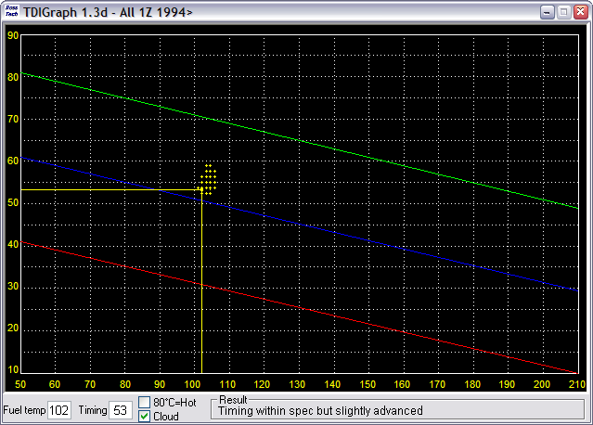
This plug-in allows you to check the injection timing setting on a TDI engine. This needs to be done after you changed the timing belt and every once in a while to keep tabs on belt stretch and pump/pulley misalignment. The standard procedure for this is to have the engine idling at operating temperature (coolant temp >85*C), go to measuring block 000 for the engine, switch to basic settings and report fields #2 (injection timing) and #9 (fuel temperature) on a special graph.
This plug-in reports the timing on the graph in real-time, so you don't need to have your manual sitting on your lap at the same time. The application also gives you a comment in the "result" field, that will tell you if all the conditions are fulfilled to check the timing (some people don't realize you need to have the engine running, for instance...) and if your timing is within specs or not.
The history of the last 100 samples is displayed as a "cloud" of points. From the size and shape of this "cloud" you can see how much "jumping around" your engine is doing, and your average timing is probably right in the middle of the cloud.
Appendix D: TDI Timing Checker cont.

Step by step:
- Start your engine
- Start VAG-COM
- Press the [Select] button
- Press the [01-Engine] button
- Press the [Measuring blocks-08] button
- Go to group 000
- Press the [Switch to basic settings] button
- Now press the [TDI Timing] button.

Note:
The TDI Timing Checker works only as a “plug-in”. You must start it using the [TDI Timing] button in VAG-COM. Starting it any other way will result in error messages and it won’t work.

Appendix E: VAG-COM Function Chart
Factory Diagnostic Tools:  VAG-1551/1552 or VAS-5051/5052  Function Number / Name | VAG-COM Release 504.1
 | KWP-1281 * | KWP-2000 **
00 Auto-Scan | Yes | Yes
01 Control Unit Info | Yes | Yes
02 Read Fault Codes | Yes | Yes
03 Output Tests | Yes | Yes
04 Basic Settings | Yes | Yes
05 Clear Fault Codes | Yes | Yes
06 Close Controller | Yes | Yes
07 Code Module | Yes | Yes
08 Measuring Blocks | Yes | Yes
09 Single Reading | Yes | Not Used
10 Adaptation | Yes | Yes
11 Login | Yes | Yes
15 View Readiness | Yes | Yes
16 Security Access | Not Used | Yes
33 Generic OBD-II | Yes | Yes
Data Logging (Exclusive to VAG-COM!) | Yes | Yes
HighSpeed Logging (Exclusive to VAG-COM!) | No | Yes
Freeze-Frame Data | Not Used | Yes
Real-Time Graphs (Exclusive to VAG-COM!) | Yes | Yes
Real-Time Gauges (Exclusive to VAG-COM!) | Yes | Yes
TDI Timing Checker (Exclusive to VAG-COM!) | Yes | Yes
Module Finder (Exclusive to VAG-COM!) | Yes | Yes
Dual K-Line Support | Yes | Yes
7-Digit SKC/PINs (VAS only) | Yes | Yes
Code Database current through MY 2006 (VAS) | Yes | Yes
Diagnostics via direct CAN connection (VAS) | Not Used | Yes
Transport Mode (VAS Only) | Not Used | Yes
* KWP-1281: The original VAG Diagnostic Protocol. Used on all diagnostic-capable systems from 1990 through model-year 2000.
** KWP-2000: The "new" VAG Diagnostic Protocol. Used on a few 2001+ ABS systems and many 2002+ Engines, Transmissions, and Airbags.
Notes:

